Market Functionality Index — Benin
Assessment period: 2026-06-05 to 2026-06-17
Methodology: Scores and tables follow databridge-current. Summaries are unweighted descriptions of assessed markets and are not population-representative country estimates.

Executive summary
The WFP Market Functionality Index assessment of Benin, conducted between 5 and 17 June 2026, covered 53 markets. The overall MFI recorded an unweighted mean of 5.56/10 and a median of 5.62/10, with market scores ranging from 3.81 to 8.04. The assessment identifies Service, Infrastructure, and Food Quality as priority dimensions for market interventions.
Service (3.55/10) recorded the lowest performance across the assessment. The unweighted mean of market-level rates for automatic itemized receipts, visible price tags, and remote purchase options was near zero, establishing a largely traditional retail environment.
Infrastructure (5.77/10) revealed widespread physical and structural limitations. While communication networks and adequate shelter were widely present, critical utility and sanitation gaps remain. The unweighted mean of market-level rates was low for closed sewage systems, walkways or emergency exits, and uninterrupted electricity, identifying a need for structural upgrades.
Food Quality (6.14/10), evaluated through strict observational methodology, highlighted distinct gaps in handling practices. While protection from cross-contamination was generally robust, the unweighted mean of market-level rates was critically low for unexpired food, continuous refrigeration, and the absence of visible spoilage.
Other dimensions performed strongly but presented specific structural constraints. Access & Protection (9.36/10) and Availability (9.81/10) recorded high scores, reflecting stable operating environments and supply for the safely accessible assessed markets. Competition (9.28/10) and Resilience (8.61/10) were robust, though supplier networks exhibited limited geographic dispersion. Assortment (7.75/10) displayed strong availability of cereal staples but lower distinct item depth. Price (8.00/10) was characterized by a strong absence of recent large price increases (9.75/10), but lower price stability and predictability (6.26/10). The Price dimension does not by itself measure affordability or beneficiary purchasing power.
Among the 15 selected priority markets, Sékou (3.81/10) and Ouègbo (3.83/10) in Atlantique recorded the lowest overall scores, severely constrained by Service and Infrastructure. Dangbo (4.43/10, Oueme) and Banikoara (4.45/10, Alibori) also faced steep constraints in Price stability and Food Quality.
Recommendations are strictly limited to further consultation and feasibility assessments. It is recommended to verify the prevalence of expired goods and monitor food spoilage. Furthermore, consultation with local market authorities is requested to assess the feasibility of upgrading basic market infrastructure, particularly regarding closed sewage systems and reliable electricity.
Analytical limitations apply to this analysis: all summaries are unweighted descriptions of included assessed markets and are not population-representative estimates. Furthermore, item eligibility uses assessed-market coverage, and the processed data do not provide reliable item-specific trader denominators.

Country context
Benin encompasses diverse ecological zones, ranging from the humid bimodal rainfall patterns in the south to the drier unimodal conditions in the north [S3]. Livelihoods are predominantly based on smallholder rainfed agriculture, focusing on staples such as maize, cassava, yams, sorghum, millet, and rice [S3]. National crop production remained favorable, with the 2025 aggregate cereal output estimated at an above-average 2.9 million tonnes [S4]. The MFI assessment recorded high Availability (9.81/10) and an absence of recent large price increases within the Price dimension, aligning with these favorable harvest conditions and observed stable local cereal prices [S4].
The northern departments, particularly Alibori and Atakora, increasingly face security challenges associated with violent extremist activity expanding from neighboring Burkina Faso and Niger [S3]. Campaigns by Sahelian armed groups, including ISSP and JNIM, operate in these borderlands [S1]. This insecurity disrupts local livelihoods and internal mobility [S3], contributing to the internal displacement of approximately 27,000 people and hosting 29,000 refugees [S4]. Despite these regional challenges, the assessed markets recorded a strong unweighted mean Access & Protection score of 9.36/10. This reflects the inherent limitation that data capture conditions only in markets that could be safely assessed, excluding areas where access is fully compromised. Additionally, environmental hazards such as recurrent flooding in the south and erratic dry spells in the north present ongoing challenges [S3], aligning with the observed infrastructural need for improved drainage and closed sewage systems in the assessed markets.

Dimension scores across assessed markets
Dimension | Mean /10 | Markets
Assortment | 7.75 | 53
Availability | 9.81 | 53
Price | 8.00 | 53
Resilience | 8.61 | 53
Competition | 9.28 | 53
Infrastructure | 5.77 | 53
Service | 3.55 | 53
Food Quality | 6.14 | 53
Access & Protection | 9.36 | 53
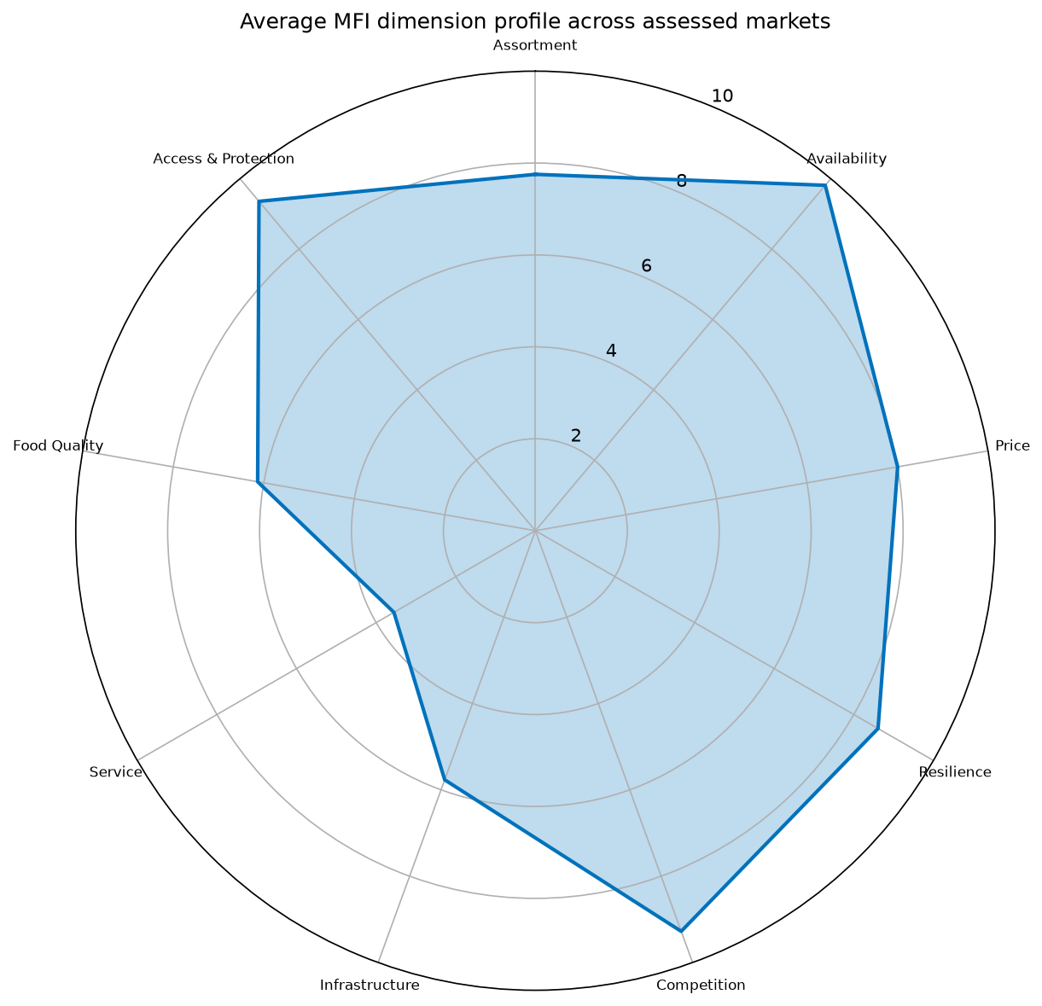
mfi radar
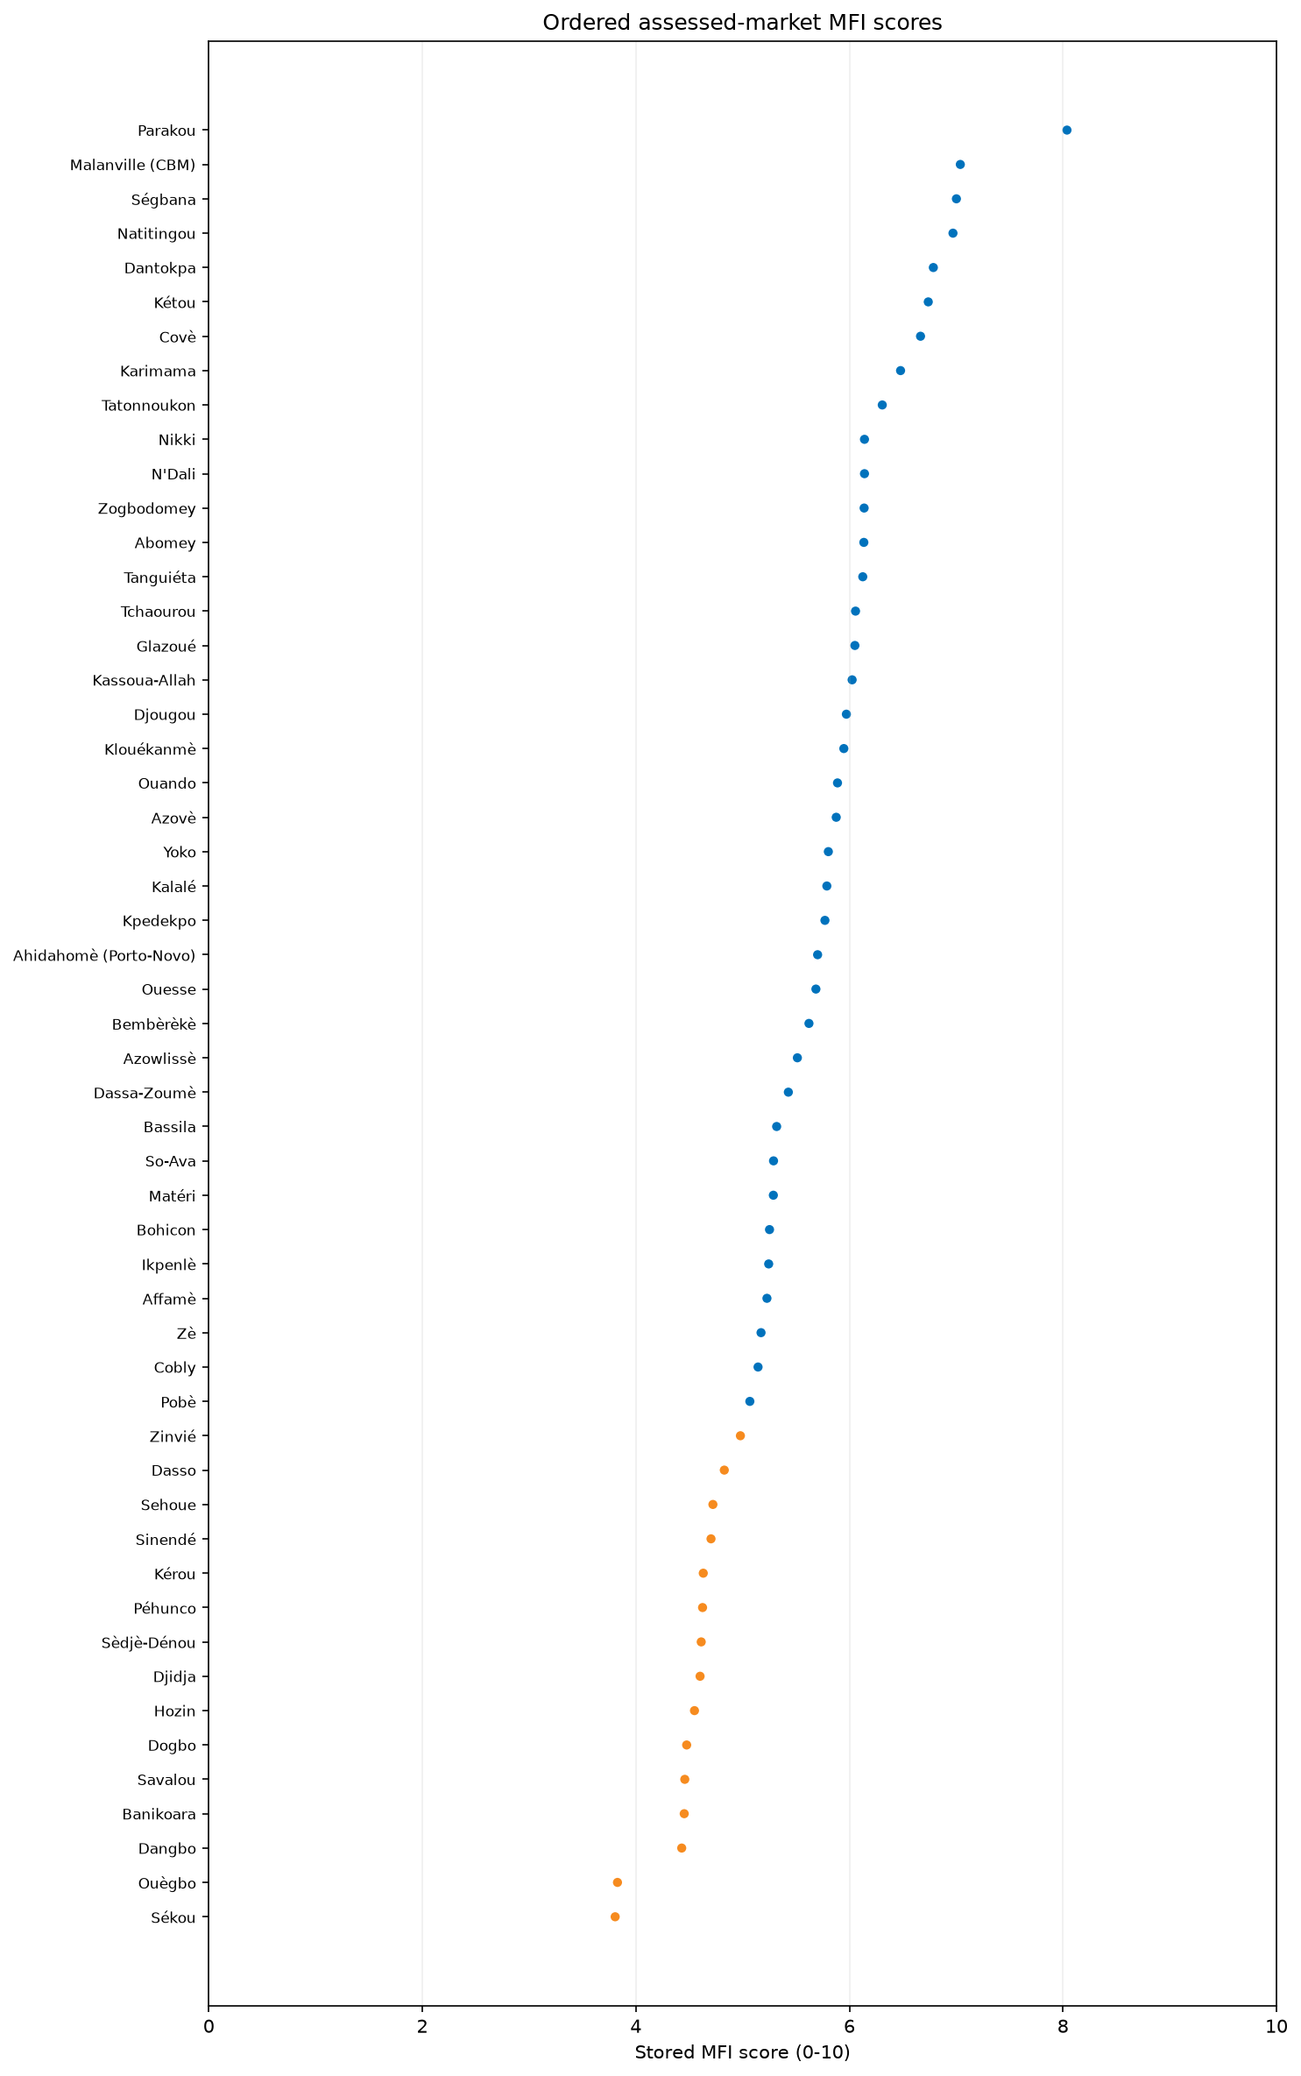
market score ranking
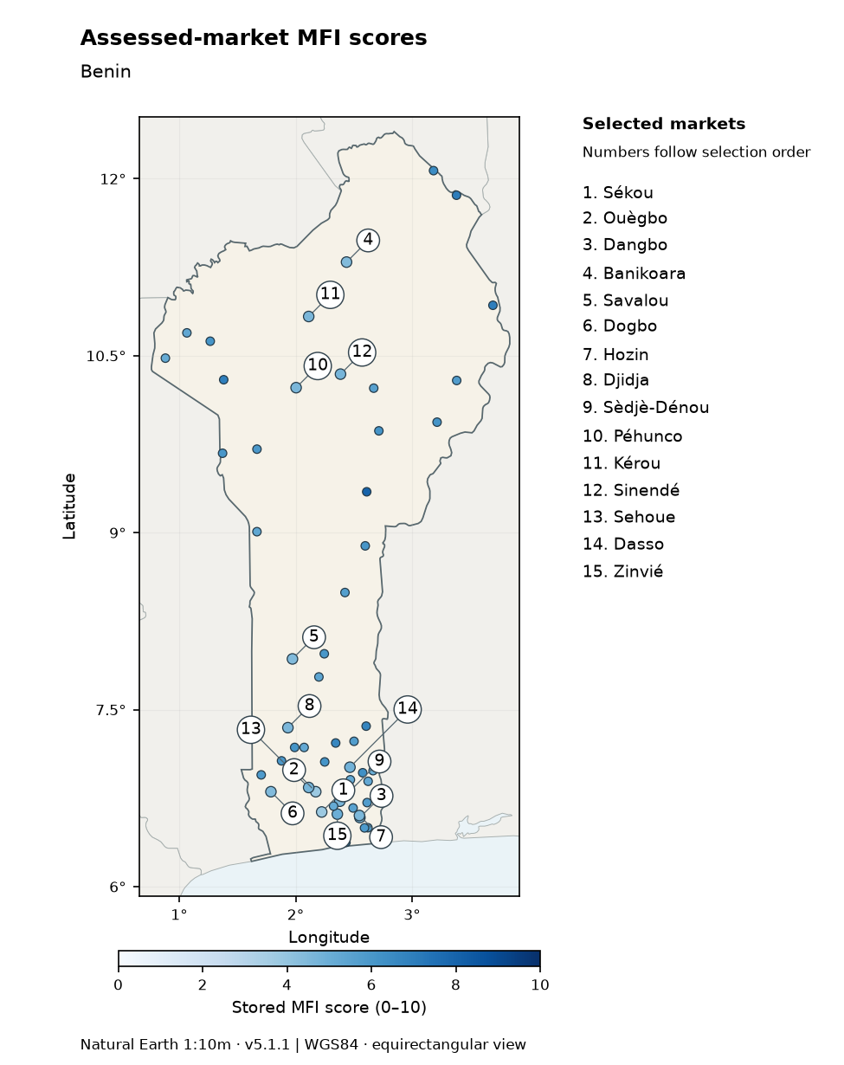
Stored assessed-market MFI scores in the assessed area. Colours show scores on the 0–10 scale; numbered callouts identify selected markets in selection order and match the side legend. Coordinates available for 53/53 assessed markets.
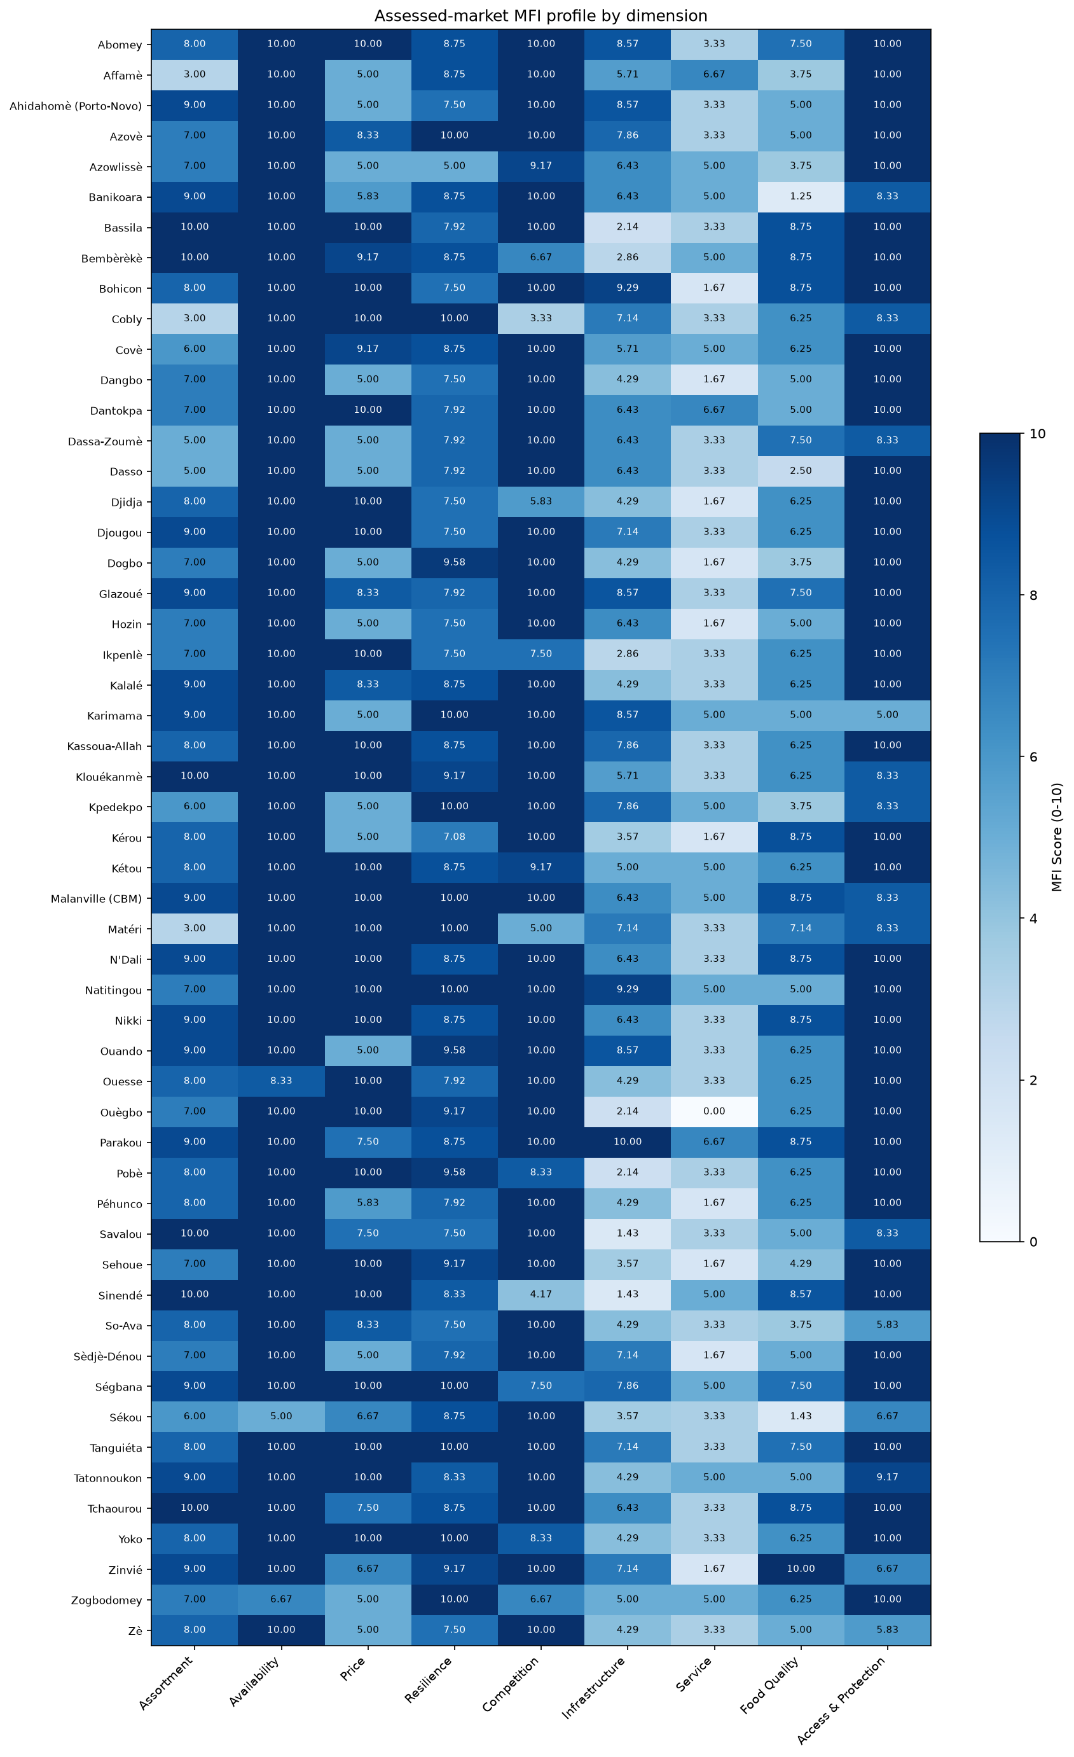
overview table

MFI dimensions

Assortment
The Assortment dimension evaluates the breadth and depth of products available in assessed markets. The overall dimension scored 7.75/10. Distributional data indicate that 33 of 53 assessed markets scored at or below the median of 8.00/10. Additionally, 47 of 53 assessed markets scored below 10/10, 20 scored below 8/10, and 3 scored below 5/10. The dimension's performance is structured around two subsections: Assortment breadth, which recorded a normalized score of 8.14/10, and Assortment depth, which scored 6.86/10.
Regarding product breadth, several categories were universally available. For cereal food, other food, and household non-food items (NFIs), the unweighted mean of market-level rates was 100%. Availability varied across other NFI categories. For WASH items, the unweighted mean of market-level rates was 96%, followed by communication items (91%), education items (85%), and shelter items (75%). Health NFIs recorded the lowest availability, where the unweighted mean of market-level rates was 23%.
Within the cereal food category, maize and rice were the most prominent items. For maize, the unweighted mean of market-level rates was 76%, and for rice, the unweighted mean of market-level rates was 57%. Sorghum (52%), millet (33%), and flour (29%) also recorded notable availability. Other cereals were less common; the unweighted mean of market-level rates was 17% for wheat, 14% for pasta, 3% for bread, and 0% for barley. The strong presence of maize, rice, sorghum, and millet reflects the primary rainfed crops and dietary staples across different livelihood zones in the country [S3].
For other food items, the unweighted mean of market-level rates was 43% for herbs, condiments, and spices, 37% for oils and fats, and 30% for milk and dairy products. Legumes, nuts, and seeds recorded an unweighted mean of market-level rates of 25%, followed by fruits and vegetables (21%), and roots and tubers (18%). Meat, fish, and eggs recorded an unweighted mean of market-level rates of 13%.
Assortment depth, which measures the number of distinct stock-keeping units (SKUs) available, was predominantly moderate. The unweighted mean of market-level rates for carrying between 51 and 200 SKUs was 42%. Additionally, the unweighted mean of market-level rates for carrying 1 to 50 SKUs was 25%, while carrying 201 to 1,000 SKUs recorded 23%, and carrying more than 1,000 SKUs recorded 11%.
Regional performance demonstrated some variation. Borgou achieved the highest unweighted regional mean Assortment score of 9.43/10. Alibori and Donga both recorded unweighted regional mean scores of 9.00/10. Conversely, Atakora recorded the lowest unweighted regional mean score at 6.17/10, with an interquartile range of 4.00 and a minimum score of 3.00/10.
Limitations of this analysis include that all findings are unweighted descriptions of the included assessed markets and do not represent population-representative estimates. Item eligibility relies on assessed-market coverage, and the processed data do not provide reliable item-specific trader denominators. Recommendations include conducting further verification of the limited availability of health NFIs to assess the feasibility of supporting expanded assortments in underserved markets.
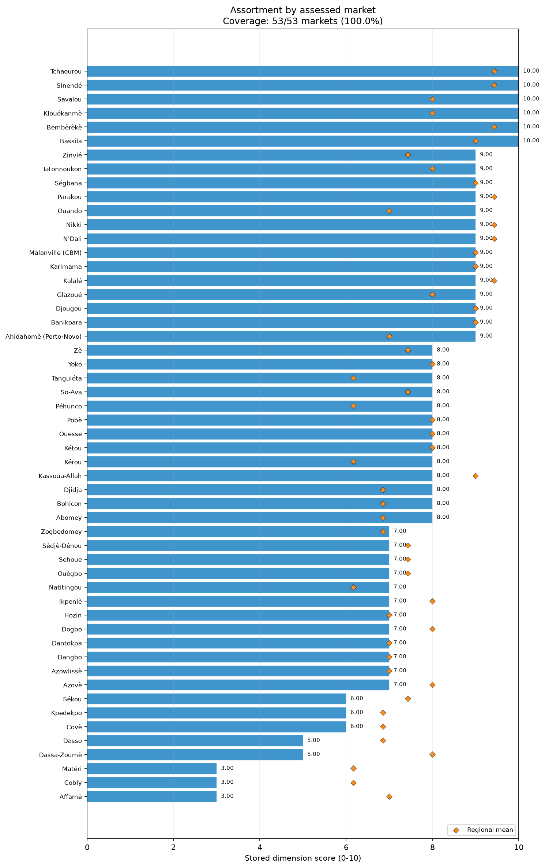
dim assortment bars

Availability
The Availability dimension measures the presence of products and the absence of scarcity or imminent runout issues. The overall Availability dimension achieved a very high score of 9.81/10. The assessment distribution shows that all 53 assessed markets scored at or below the median of 10.00/10. Only 3 of 53 assessed markets scored below 10/10, 2 scored below 8/10, and 1 market scored below 6/10. The dimension comprises two closely aligned subsections: Absence of scarcity, scoring 9.84/10, and Absence of imminent runout, scoring 9.78/10.
Markets largely operated without significant supply shortages across major product groups. Within the Absence of scarcity subsection, the unweighted mean of market-level rates for the absence of scarcity in non-food items (NFIs) was 95%. For cereal food and other food, the unweighted mean of market-level rates for the absence of scarcity stood at 94% and 93%, respectively. The Absence of imminent runout subsection displayed identical strengths. The unweighted mean of market-level rates for not running out of NFIs was 95%, while the rates for not running out of cereal food and other food were 92% and 90%, respectively. This robust availability aligns with the broader agricultural context; [S4] notes that the 2025 aggregate cereal production was estimated to be above average, supported by effective interventions providing seeds, fertilizers, and input subsidies.
When analyzing specific item drivers, reported problems were generally minimal but identifiable in a few specific goods. The unweighted mean of market-level rates for the scarcity problem rate was 12% for communication NFIs and 11% for wheat. For runout problem rates, the unweighted mean of market-level rates was 14% for other non-cereal food, 9% for wheat, and 6% for both herbs, condiments, and spices, as well as fruits and vegetables. Health NFIs recorded a 33% problem rate for both scarcity and runout; however, this item generated an applicability warning due to insufficient market coverage, being relevant in only 3 assessed markets. Major staple cereals faced extremely low constraints; the unweighted mean of market-level rates for scarcity was 1% for maize and 2% for rice, with runout rates at 4% for both items.
Regional scores reflected strong countrywide availability. Alibori, Atakora, Borgou, Couffo, Donga, Littoral, Oueme, and Plateau all attained the maximum unweighted regional mean Availability score of 10.00/10. Atlantique recorded the lowest unweighted regional mean score, yet still achieved a high 9.29/10, with an interquartile range of 0.00 and a minimum score of 5.00/10, indicating that availability constraints were highly localized rather than widespread.
Analytical limitations include that these figures are unweighted descriptions of included assessed markets, not population-representative country estimates. The data also lack reliable item-specific trader denominators. Recommendations are limited to conducting continued monitoring of specific supply chains that exhibited early signs of runout, such as other non-cereal foods and wheat, to verify the extent of these localized constraints.
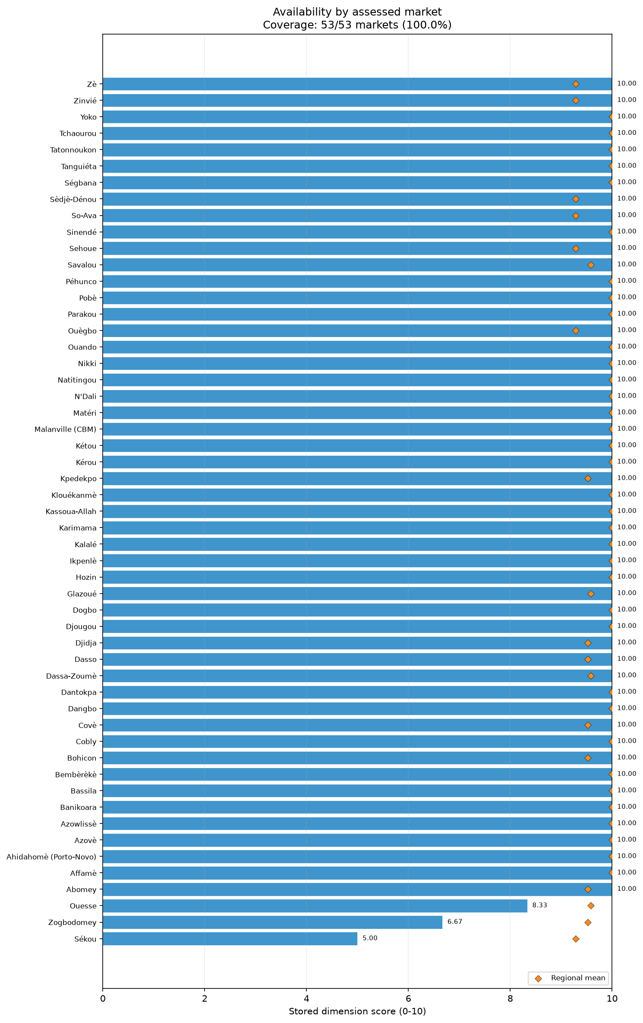
dim availability bars

Price
The Price dimension evaluates the stability and predictability of prices, alongside the absence of recent large price increases. The overall Price score was 8.00/10. The distribution of market scores shows that 28 of 53 assessed markets scored at or below the median of 9.17/10. Furthermore, 28 of 53 assessed markets scored below 10/10, 22 scored below 8/10, and 17 scored below 6/10, indicating moderate variability in pricing conditions. The overall score is heavily influenced by the Absence of recent large price increases subsection, which scored a strong 9.75/10, while the Price stability and predictability subsection scored much lower at 6.26/10.
Traders predominantly indicated that recent large price increases were absent across major categories. The unweighted mean of market-level rates for the absence of recent price increases was 93% for cereal food, 92% for non-food items (NFIs), and 90% for other food. These metrics are corroborated by [S4], which observes that retail prices of locally produced rice and maize remained stable between January and April 2026, while sorghum prices decreased due to ample carryover stocks and weak external demand. At the item level, the unweighted mean of market-level rates for price increases was 13% for fruits and vegetables, 9% for wheat, and 7% for roots and tubers.
Despite the lack of acute price spikes, price stability and predictability presented a significant constraint. The unweighted mean of market-level rates for price stability was 61% for cereal food, 59% for NFIs, and 57% for other food. When examining item-specific instability rates, the unweighted mean of market-level rates was 42% for herbs, condiments, and spices, 40% for household items, and 38% for both flour and fruits and vegetables. Roots and tubers recorded an instability rate of 37%. Even widely consumed staples exhibited volatility; the unweighted mean of market-level rates for price instability was 35% for maize and 28% for rice. While [S3] notes that rising food, fuel, and agricultural input prices are broader concerns, the MFI Price dimension strictly measures the consistency and trajectory of prices for traders, and does not by itself measure affordability or beneficiary purchasing power.
Regional pricing dynamics highlighted areas of acute constraint. Donga, Littoral, and Plateau recorded the highest unweighted regional mean Price scores, all attaining 10.00/10. In contrast, Oueme recorded the lowest unweighted regional mean Price score at 5.00/10, with zero interquartile variance. Atlantique recorded an unweighted regional mean of 7.38/10. Atakora showed wide variability, with an interquartile range of 3.12, an unweighted mean of 8.47/10, and a minimum score of 5.00/10.
As a limitation, these findings are unweighted descriptions of the assessed markets rather than population-representative estimates. Item eligibility is based on assessed-market coverage without reliable item-specific trader denominators. It is recommended to assess the feasibility of further monitoring price predictability for highly volatile items, and to verify the specific factors driving lower price stability in Oueme and Atlantique.
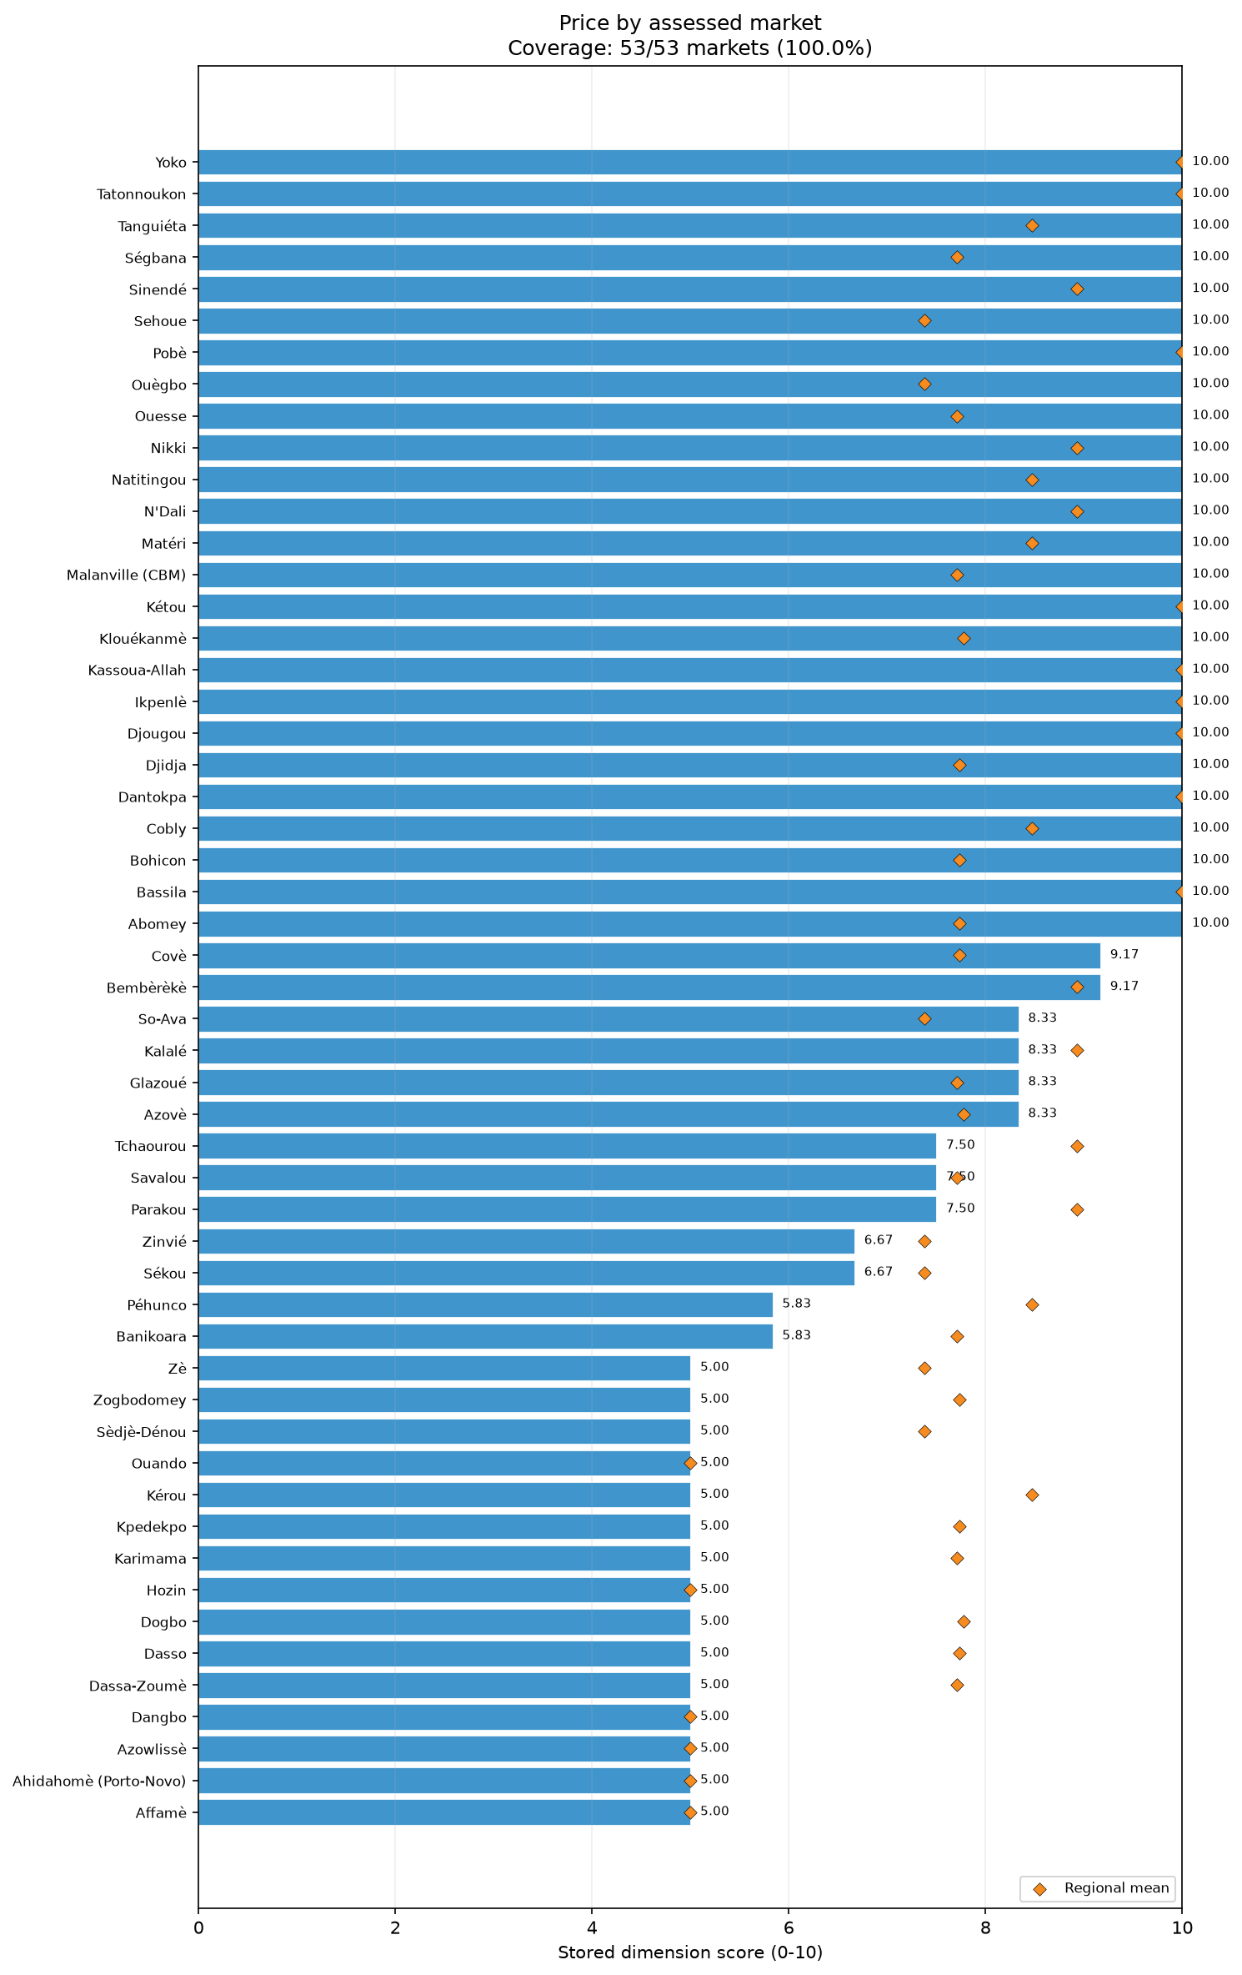
dim price bars

Resilience
The Resilience dimension assesses the vulnerability of supply chains to disruption and their overall responsiveness. The overall Resilience score was 8.61/10, with 35 of 53 assessed markets scoring at or below the median of 8.75/10. Additionally, 42 of 53 assessed markets scored below 10/10, 20 scored below 8/10, and only 1 market scored below 6/10. The score is underpinned by the Supply-chain responsiveness subsection, which attained a high normalized score of 9.91/10, and the Low vulnerability to disruption subsection, which scored 8.18/10.
Supply-chain responsiveness was highly robust across the assessed markets. For replenishment expected within one week, the unweighted mean of market-level rates was 96%. Furthermore, the unweighted mean of market-level rates for stock expected to last at least one week was 90%. These metrics indicate reliable inventory turnover and short lead times across major commodity groups.
Vulnerabilities were more pronounced within the structure of supplier networks. Single-supplier dependence was largely absent; the unweighted mean of market-level rates for the absence of single-supplier dependence was 95% for non-food items (NFIs), 93% for other food, and 89% for cereal food. The complexity of supplier networks, represented by supplier diversity, also scored well. The unweighted mean of market-level rates for supplier diversity was 93% for other food, 92% for cereal food, and 91% for NFIs.
However, geographic supplier dispersion emerged as a primary constraint. The unweighted mean of market-level rates for geographic supplier dispersion was only 36% for cereal food. For other food and NFIs, the unweighted mean of market-level rates for geographic dispersion stood at 48% and 63%, respectively. This concentration of supplier locations identifies a structural pattern where, despite sourcing from multiple individual providers, traders rely heavily on localized geographic areas to supply their goods.
Regional performance displayed a narrow range of generally favorable scores, though some variations were present. Alibori recorded the highest unweighted regional mean Resilience score at 9.69/10, followed closely by Couffo at 9.58/10. Oueme recorded the lowest unweighted regional mean score at 7.64/10, featuring an interquartile range of 0.94 and a relatively wide score range of 4.58. Collines and Littoral also recorded scores below the national average, at 7.81/10 and 7.92/10, respectively. Donga recorded an unweighted regional mean of 8.06/10 with a minimum score of 7.50/10.
Limitations of this assessment include that the results are authoritative, unweighted descriptions of the assessed markets and are not representative estimates for the entire country. The processed data also do not provide reliable item-specific trader denominators for item-level analysis. Given the evidenced lack of geographic supplier dispersion, it is recommended to consult with supply chain actors to verify the feasibility of diversifying supplier source locations, particularly for cereal and other food commodities, to strengthen overall market resilience.
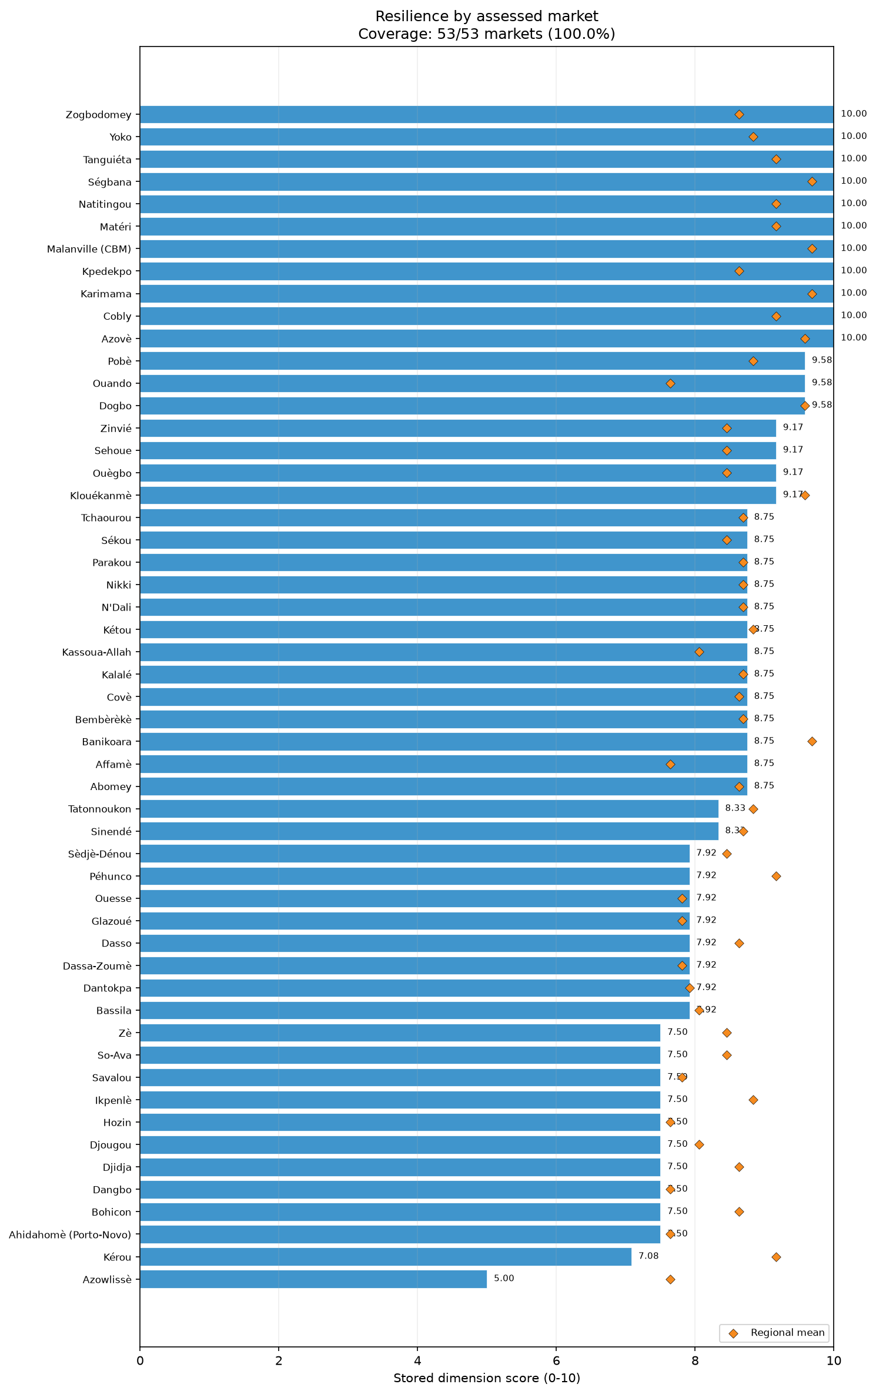
dim resilience bars

Competition
The Competition dimension measures the concentration of traders and the absence of single-trader monopolies within markets. The overall Competition score was strong at 9.28/10. The distributional data show that all 53 assessed markets scored at or below the median of 10.00/10. A total of 12 out of 53 assessed markets scored below 10/10, 8 scored below 8/10, and 4 scored below 6/10. Furthermore, only 2 assessed markets scored below 5/10, indicating that severe competition deficits are rare. The dimension's high performance is composed of the Absence of single-trader control subsection, which scored 9.56/10, and the Sufficient trader competition subsection, which scored 8.99/10.
Market competition was generally robust, with monopolistic control largely absent across the assessed locations. For the Absence of single-trader control subsection, 100% of assessed markets reported no single-trader control for cereal food. This metric remained similarly high for non-food items (NFIs) at 98% of assessed markets, and for other food at 94% of assessed markets.
Trader concentration metrics further highlight a competitive market environment. The presence of at least five independent traders per product group serves as the metric for sufficient trader concentration. This threshold was met for cereal food in 94% of assessed markets. NFIs followed closely, with 92% of assessed markets reporting at least five traders. For other food, 88% of assessed markets recorded sufficient trader concentration. The near-universal lack of monopolies for essential staples like cereals reflects an open structural environment. The slightly lower concentration of traders for the other food category indicates a distinct market structure compared to basic cereals.
Regional data revealed that five regions—Atlantique, Collines, Couffo, Donga, and Littoral—achieved the maximum unweighted regional mean Competition score of 10.00/10, with zero variability in their scores. Conversely, Atakora recorded the lowest unweighted regional mean Competition score at 8.06/10. Atakora also exhibited the widest regional variability, with an interquartile range of 3.75, a minimum market score of 3.33/10, and a score range of 6.67, identifying the presence of specific markets within the region that lack sufficient trader concentration. Borgou also displayed localized constraints, recording an unweighted regional mean of 8.69/10 with a minimum score of 4.17/10 and a score range of 5.83. Oueme and Zou recorded unweighted regional mean scores of 9.86/10 and 8.93/10, respectively.
A key methodological limitation is that the results describe only the included assessed markets and do not serve as population-representative country estimates. Additionally, item-specific trader denominators are unavailable for the processed data. Based on the constraints observed in specific geographic areas, recommendations include conducting further verification of trader concentration in the lowest-scoring markets of Atakora and Borgou. Furthermore, future assessments should explore the feasibility of targeted interventions that might encourage new vendors to enter these specific local markets to enhance structural competition.
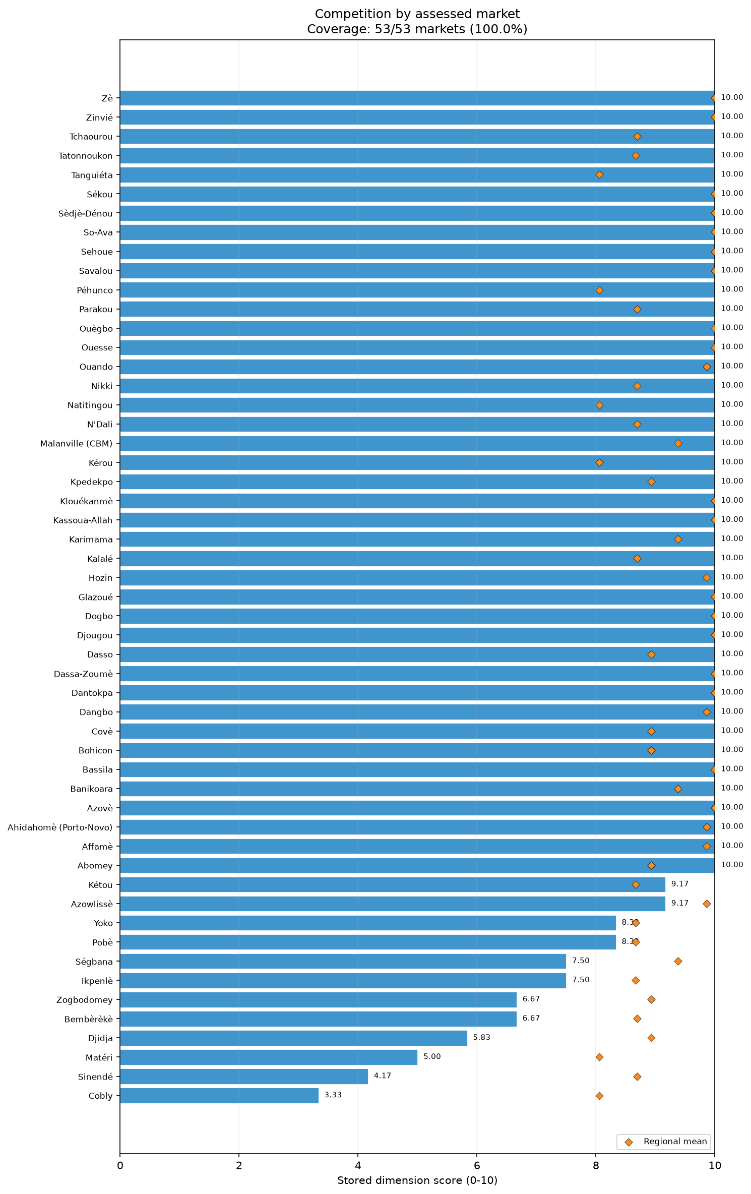
dim competition bars

Infrastructure
The Infrastructure dimension evaluates the physical condition and available facilities within market environments. The overall Infrastructure score was low at 5.77/10, identifying widespread physical and structural constraints. The distributional data show that 35 of 53 assessed markets scored at or below the median of 6.43/10. Additionally, 52 of 53 assessed markets scored below 10/10, 35 scored below 7/10, and 20 scored below 5/10. The overall dimension score is derived from the Infrastructure condition subsection, which scored 5.94/10, and the Infrastructure features subsection, which scored 5.64/10.
Descriptive analysis of the physical state of market facilities shows moderate conditions. Specifically, 57% of assessed markets were classified as being in good condition. A further 66% of assessed markets were described as being in medium condition, while 28% were classified as being in poor condition.
The availability of specific infrastructure features revealed significant gaps in basic utilities and sanitation. A reliable communication network was present in 85% of assessed markets, and 83% of assessed markets featured adequate shelter. However, essential public health and operational facilities were frequently lacking. Toilets were available in 74% of assessed markets, and dedicated waste collection was present in 64%. Uninterrupted electricity was reported in only 57% of assessed markets, and water availability was verified in just 51%. The most critical deficiencies were observed in drainage and structural safety features. Closed sewage systems were available in only 26% of assessed markets, and walkways and emergency exits were present in merely 11%. The lack of robust drainage infrastructure is particularly notable given the external context provided in [S3], which highlights recurrent flooding in southern and riverine areas as a persistent environmental hazard.
Regional disparities in infrastructure provision were pronounced. Alibori achieved the highest unweighted regional mean Infrastructure score of 7.32/10, with a minimum score of 6.43/10. In contrast, Plateau recorded the lowest unweighted regional mean score at 3.71/10. Several other regions registered low averages, including Atlantique (4.59/10), Collines (5.18/10), and Borgou (5.41/10). Borgou exhibited severe intra-regional disparities, recording an interquartile range of 2.86 and scores ranging from a minimum of 1.43 to a maximum of 10.00/10, indicating highly uneven infrastructural development across its markets. Atakora also showed wide variability, with a score range of 5.71 and an unweighted mean of 6.43/10.
Analytical limitations include the fact that these findings are unweighted descriptions of the specific assessed markets and do not serve as representative country estimates. Furthermore, the dataset does not support item-specific trader denominators. Based on the evidenced constraints, it is recommended to consult with local market authorities regarding the feasibility of upgrading basic market features. Recommendations specifically include assessing options for improving water availability, closed sewage systems, and emergency exits to address documented infrastructural deficits.
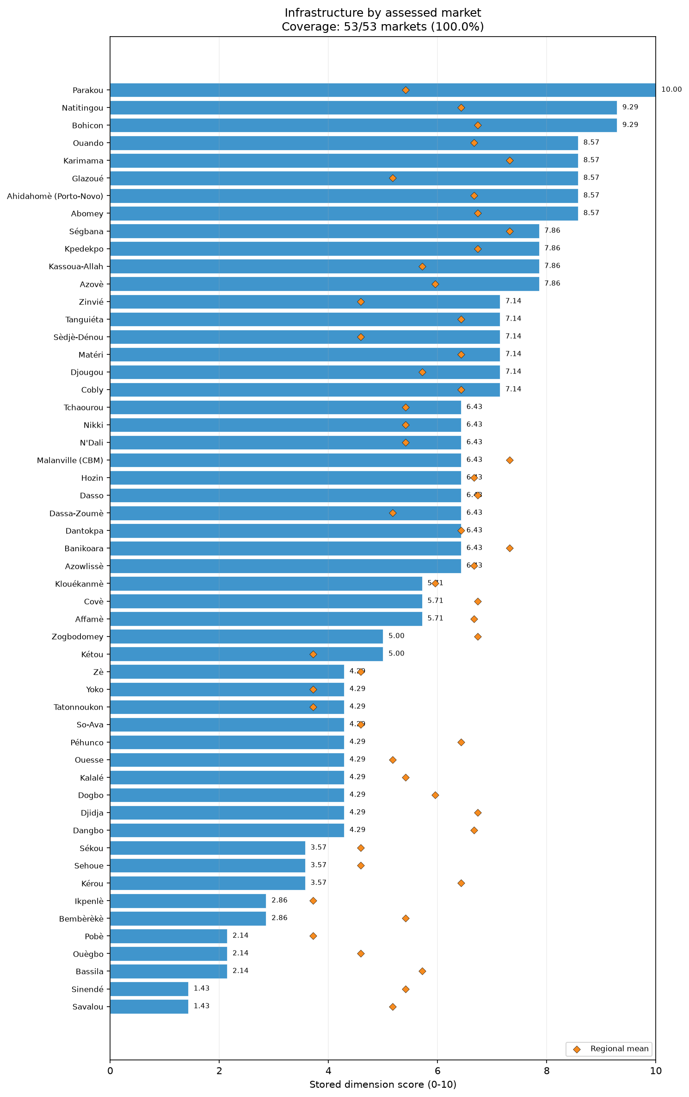
dim infrastructure bars
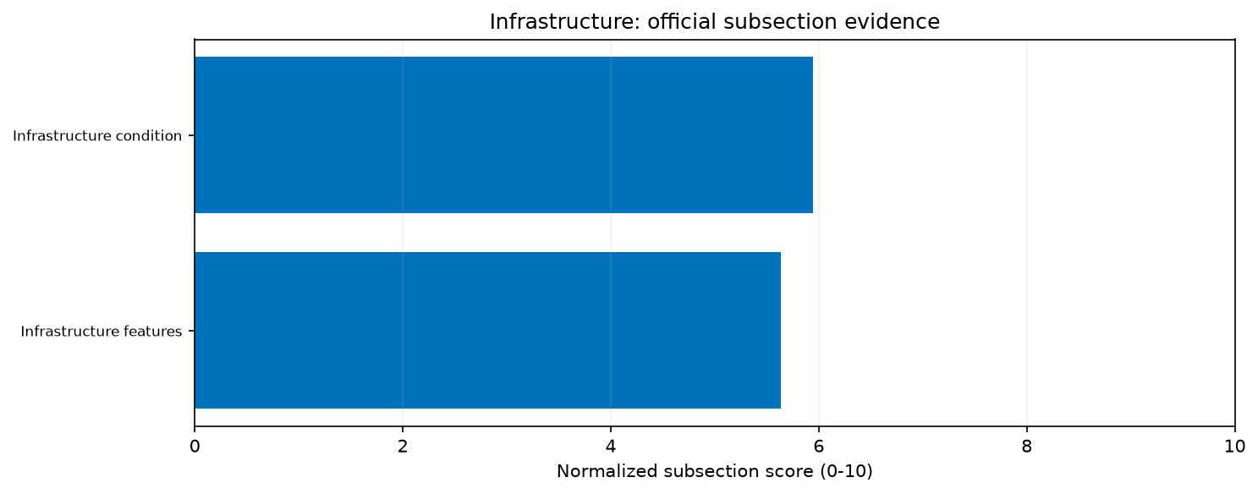
priority infrastructure subsections
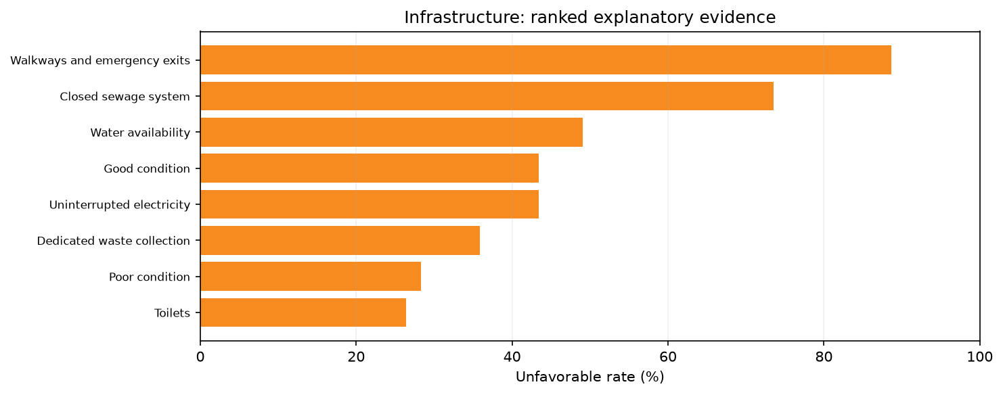
priority infrastructure drivers

Service
The Service dimension captures the quality of shopping and checkout experiences provided to customers. Overall, this dimension yielded the lowest performance in the assessment, scoring just 3.55/10. The distribution of scores was heavily skewed toward the lower end, as 37 of 53 assessed markets scored at or below the median of 3.33/10. Furthermore, all 53 assessed markets scored below 10/10, 50 scored below 6/10, and 37 scored below 4/10, confirming widespread service constraints. The dimension comprises the Shopping service subsection, scoring 3.58/10, and the Checkout service subsection, scoring 3.52/10.
Shopping services were characterized by a singular strength amidst widespread limitations. Specifically, the unweighted mean of market-level rates for products displayed for easy selection was 96%. However, other retail conveniences were virtually absent. The unweighted mean of market-level rates was only 6.9% for the availability of remote purchase options. Similarly, the unweighted mean of market-level rates for visible price tags was just 6.2%. The lack of visible pricing establishes that retail environments are structurally informal across the assessed locations.
Checkout services displayed similarly severe constraints. The unweighted mean of market-level rates for providing a checkout wait time below ten minutes was 56.5%, indicating that extended transaction processes are relatively common. Furthermore, the unweighted mean of market-level rates for accepting multiple forms of payment was only 44.4%, meaning that reliance on a single payment method remains the standard operational practice. The provision of automatic itemized receipts was fundamentally non-existent, as the unweighted mean of market-level rates was recorded at only 0.1%. The near-total absence of formal itemized receipts, multiple payment options, and visible pricing reflects a traditional retail structure in the assessed markets.
Regional averages heavily reflected these systemic shortfalls. Littoral attained the highest unweighted regional mean Service score, though it was still a modest 6.67/10. Atlantique recorded the lowest unweighted regional mean score at 2.14/10, with a maximum score in the region reaching only 3.33/10. Most regions clustered tightly around the 3.33 to 5.00 range, including Alibori (5.00/10), Collines (3.33/10), Donga (3.33/10), and Oueme (3.61/10). This regional homogeneity underscores that limited customer service features are a standard operational reality rather than a localized or regional anomaly. Atakora recorded an unweighted mean of 3.06/10, with scores ranging from 1.67 to 5.00/10.
The limitations of this analysis are that it relies entirely on unweighted descriptions of included assessed markets, not population-representative estimates, and item-specific trader denominators are unavailable. Based strictly on the evidenced constraints, recommendations include monitoring the evolution of checkout wait times. Furthermore, it is recommended to assess the feasibility of supporting localized efforts to introduce visible price tags and expand accepted payment methods within these specific market environments.
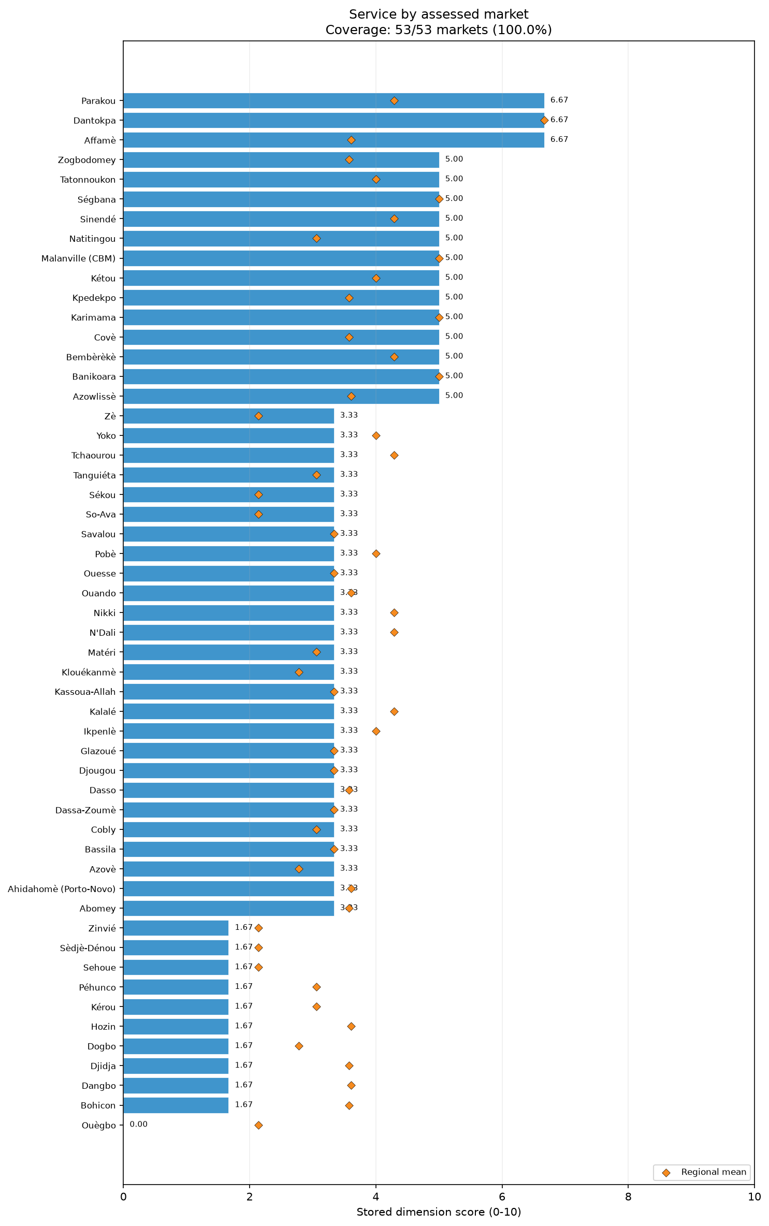
dim service bars
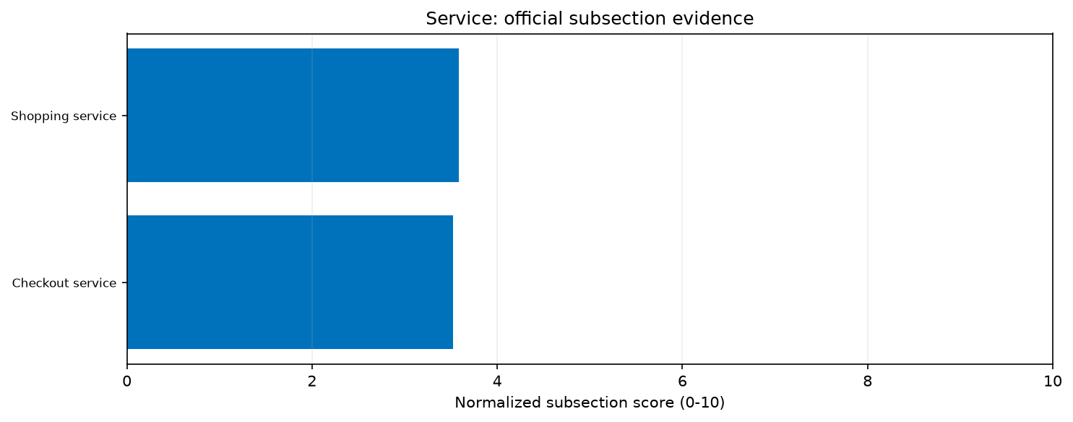
priority service subsections
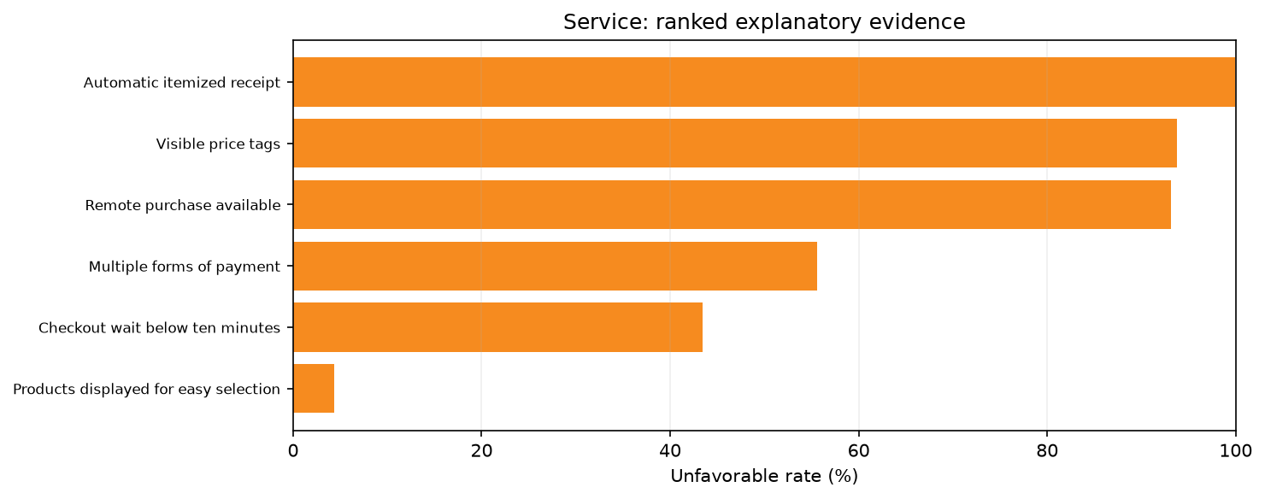
priority service drivers

Food Quality
The Food Quality dimension evaluates the handling, packaging, and condition of food items based on observational criteria. The overall Food Quality score was 6.14/10, indicating moderate constraints across the assessed markets. Distributionally, 36 of 53 assessed markets scored at or below the median of 6.25/10, with 52 markets scoring below 10/10, 42 below 8/10, and 20 below 6/10. The dimension's architecture includes the validation of applicable quality conditions, which scored 7.92/10, and the extent to which these conditions are satisfied, which scored 6.13/10.
Market handling practices showed distinct strengths in hygiene and contamination prevention. The unweighted mean of market-level rates was 94% for food protected from contaminants. Similarly, the unweighted mean of market-level rates was 94% for fresh food separated from animal-origin food, a critical practice for mitigating cross-contamination. Packaging conditions were also generally robust. The unweighted mean of market-level rates reached 87% for prepackaged food remaining intact and labelled, and 85% for general packaging remaining intact.
However, significant operational constraints were identified regarding freshness, expiration, and temperature control. The unweighted mean of market-level rates was only 47% for no visible spoilage, establishing that spoilage issues were prevalent across multiple markets. For goods requiring temperature control, the unweighted mean of market-level rates was 43% for applicable food being refrigerated. Furthermore, the unweighted mean of market-level rates was just 38% for refrigeration continuously working. Most critically, the unweighted mean of market-level rates was an alarmingly low 5.7% for products not expired. This establishes that the presence of expired goods is a severe issue across the assessed markets, contrasting sharply with the positive practices observed in cross-contamination prevention.
Regional performances highlighted disparities in food handling and quality outcomes. Borgou registered the highest unweighted regional mean Food Quality score at 8.37/10, with an interquartile range of 0.09 and scores tightly clustered between 6.25 and 8.75/10. Conversely, Oueme recorded the lowest unweighted regional mean score of 4.79/10. Atlantique and Couffo also exhibited low regional averages, scoring 5.10/10 and 5.00/10, respectively, indicating concentrated quality constraints in specific southern and central areas. Alibori demonstrated the widest internal variance, with a score range of 7.50 and a minimum score of 1.25/10, despite an unweighted regional mean of 5.63/10.
A limitation of this analysis is that all findings are unweighted descriptions of the assessed markets rather than population-representative country estimates. Additionally, item eligibility and specific trader denominators are constrained by market-level coverage parameters. The special Food Quality methodology emphasizes observational criteria over self-reported data. Based on the severe constraints recorded, it is recommended to consult with local health and market authorities to verify the widespread prevalence of expired products. Further feasibility assessments should investigate options for strengthening cold-chain storage to reduce visible spoilage.
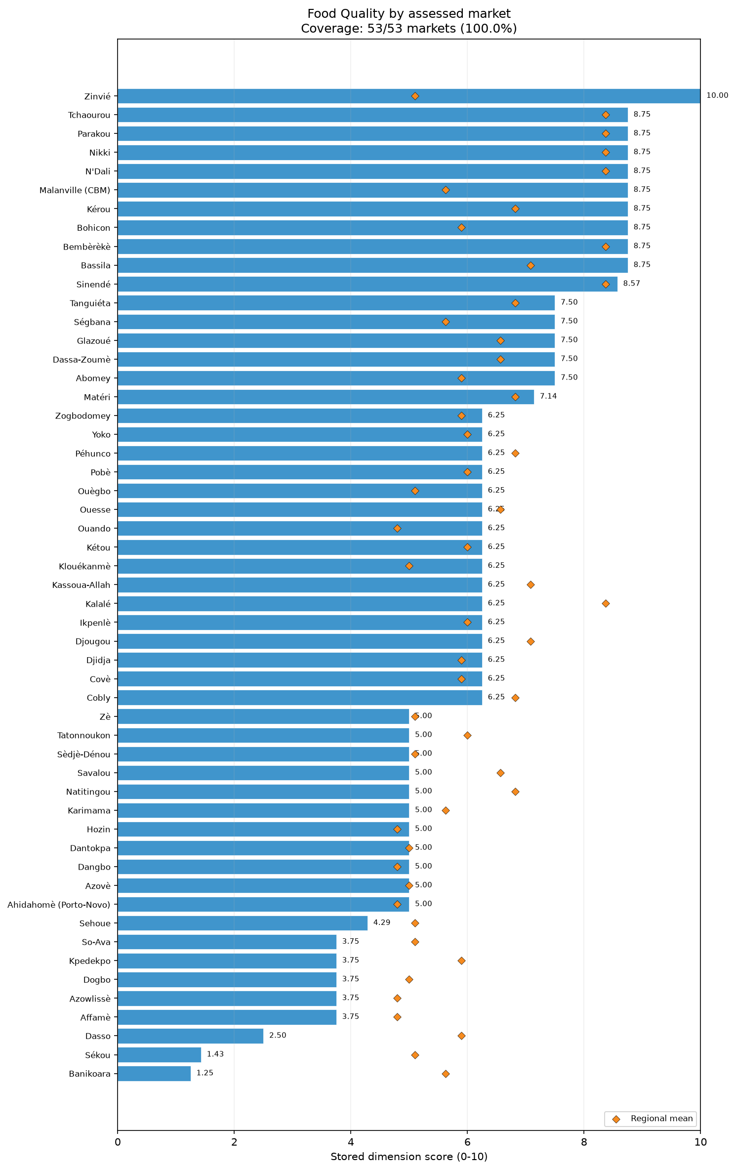
dim food quality bars
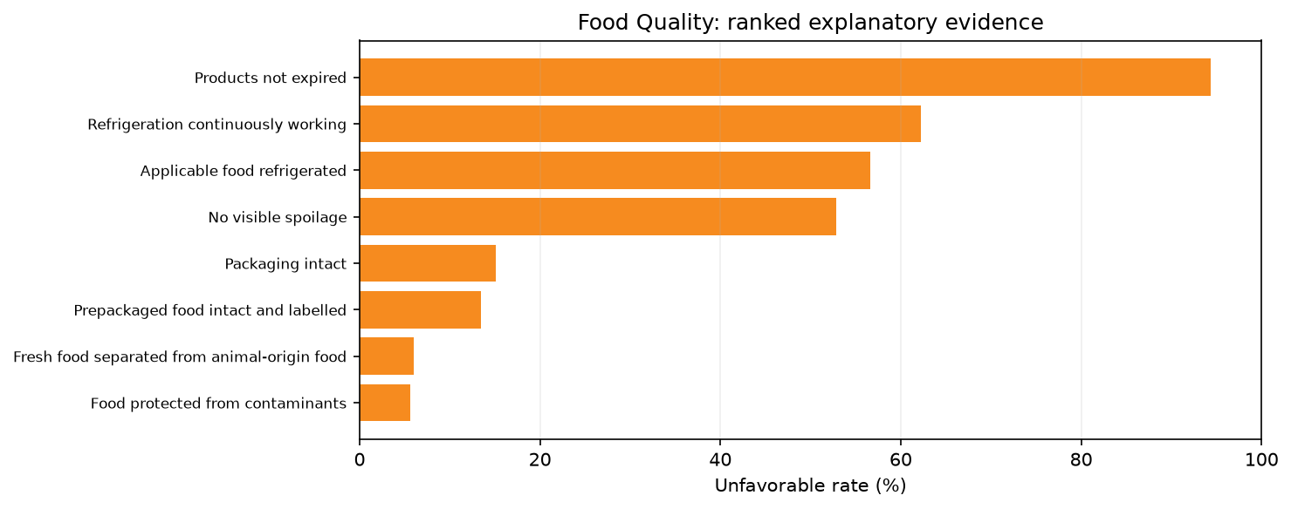
priority food quality drivers

Access & Protection
The Access & Protection dimension evaluates the physical accessibility and the security environment of the assessed markets. The overall dimension performed exceptionally well, achieving a score of 9.36/10. Distributional analysis reveals that all 53 included assessed markets scored at or below the median of 10.00/10. Furthermore, 14 of 53 assessed markets scored below 10/10, 5 scored below 8/10, and only 3 scored below 6/10. The overall dimension score is a synthesis of two highly performing subsections: the Protection and security subsection, which scored 9.53/10, and the Physical access subsection, which scored 9.18/10.
The security environment in the assessed markets was demonstrated to be highly stable across multiple indicators. Within the Protection and security subsection, 98% of assessed markets reported the absence of social barriers. Additionally, 96% of assessed markets reported no general security issues, and 92% of assessed markets recorded the absence of physical threats. External context highlights significant regional security dynamics; [S1] details the expansion of violent extremist campaigns by Sahelian jihadist groups, including the Islamic State Sahel Province (ISSP) and Jama’at Nusrat al-Islam wal-Muslimin (JNIM), particularly along the Benin, Niger, and Nigeria borderlands. Furthermore, [S3] notes that acute food insecurity is a growing concern in northern areas, such as the Alibori and Atakora departments, due to increasing conflict and insecurity. However, these broader regional security trends did not broadly compromise the internal protection scores of the specific markets successfully assessed in this index.
Physical access was similarly robust but faced environmental constraints in a subset of locations. For the Physical access subsection, 100% of assessed markets reported no disaster-related access limitations. Moreover, 92% of assessed markets were located not far from a major road network. Seasonal access difficulty was the most prominent constraint within this dimension, with 79% of assessed markets reporting no seasonal access difficulty. The remaining markets facing seasonal constraints align with the contextual presence of recurrent flooding in southern and riverine areas, as well as erratic rainfall in the north [S3].
Regional averages reflected strong performance across the country. Borgou, Donga, Littoral, and Oueme tied for the highest unweighted regional mean Access & Protection score at a perfect 10.00/10. Atakora also showed strong performance with an unweighted regional mean of 9.44/10, despite the broader regional security context, though its minimum score was 8.33/10. Alibori, another conflict-affected region, averaged 7.92/10, with an interquartile range of 1.25 and scores ranging from 5.00 to 10.00/10. Atlantique recorded the lowest unweighted regional mean score at 7.86/10, with a minimum score of 5.83/10 and a relatively wide score range of 4.17.
Analytical limitations must be noted. All summaries are unweighted descriptions of included assessed markets and are not population-representative country estimates. The data reflect conditions only in markets that could be safely assessed, inherently excluding areas where access and protection are fully compromised. It is recommended to verify the localized security constraints in Alibori and Atlantique and monitor seasonal access difficulties during rainy seasons.
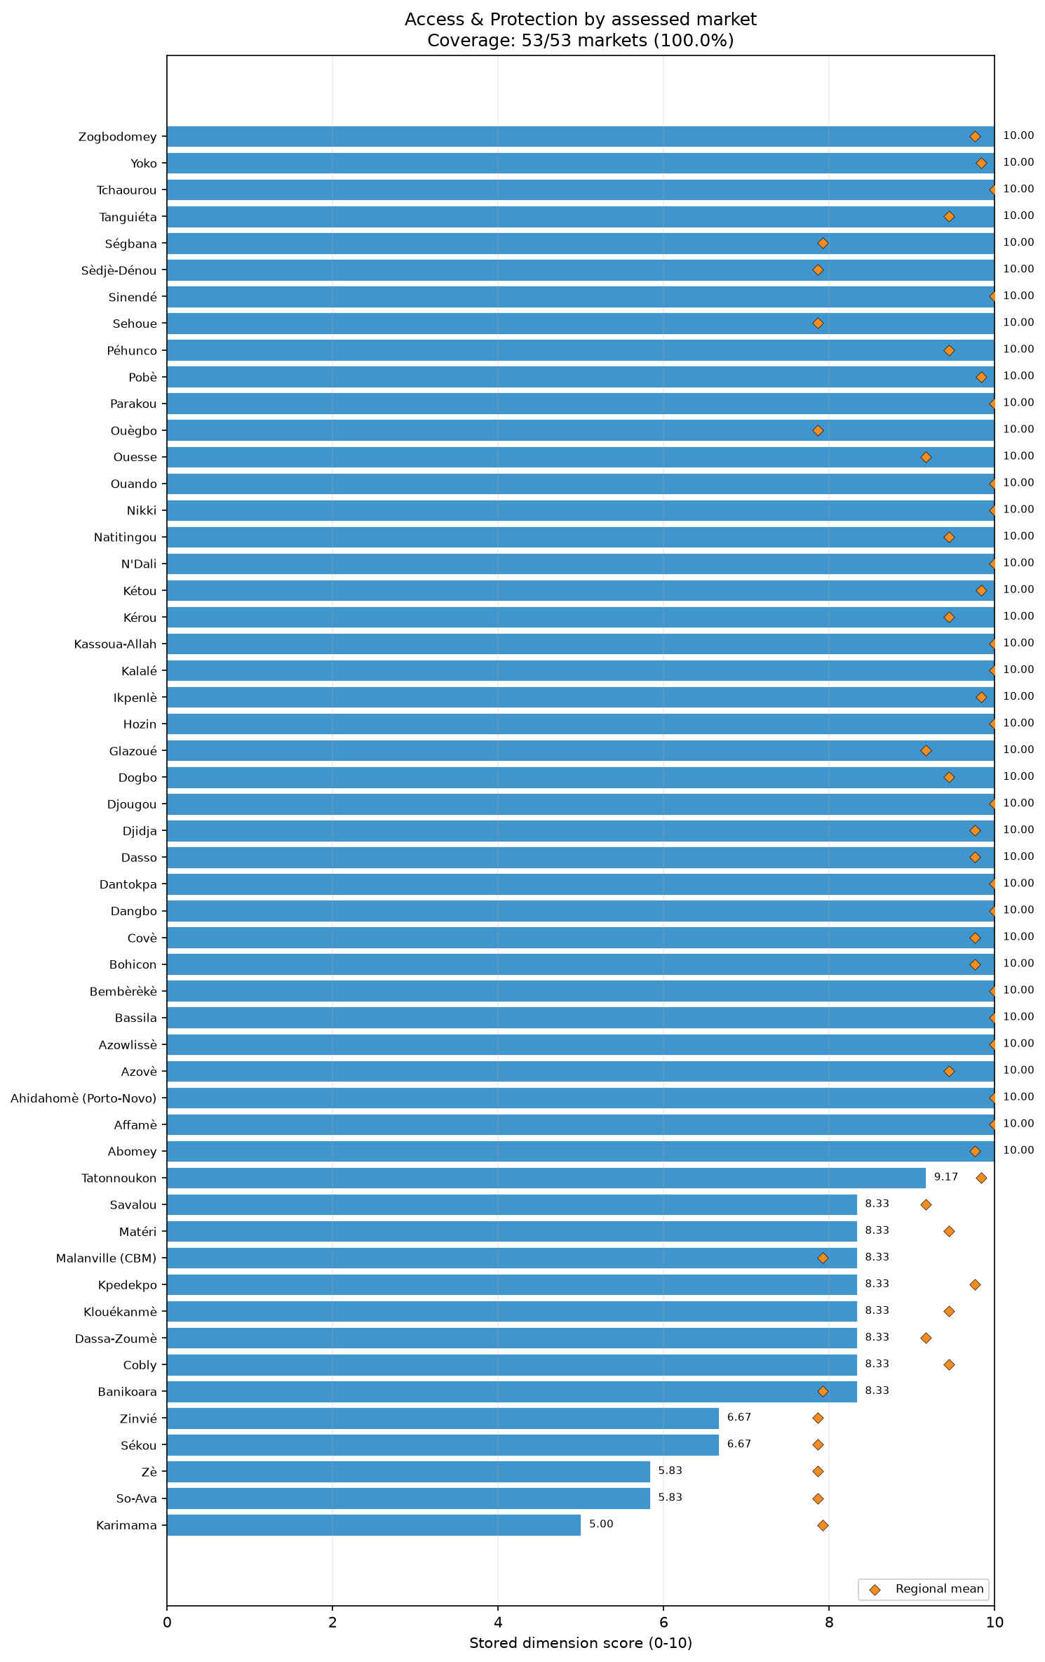
dim access and protection bars

Selected markets

Sékou
In Sékou, Atlantique, the assessed market recorded an overall MFI score of 3.8. The most significant constraints were found in the Food Quality (1.4), Service (3.3), and Infrastructure (3.6) dimensions. Within Food Quality, the market satisfied 1.4 out of a maximum of 7.0 applicable conditions. The condition recorded for this market was universally unfavorable regarding continuous refrigeration, product expiry, visible spoilage, and intact packaging. Service was equally weak across checkout and shopping components, with all surveyed traders reporting a lack of automatic itemized receipts and visible price tags, while 91% lacked short waits and remote purchase options. Infrastructure was hampered by widespread issues; the condition recorded for this market was universally unfavorable for general market condition, closed sewage systems, communication networks, and uninterrupted electricity. Based on this evidence, it is recommended to verify the feasibility of investments in essential market infrastructure, particularly electricity and sewage systems, and to monitor food quality standards, especially regarding spoilage and refrigeration. The analysis is limited to the assessed market and is not a population-representative estimate.

Ouègbo
Ouègbo market in Atlantique exhibited an overall score of 3.8, with operational bottlenecks primarily concentrated in Service (0.0), Infrastructure (2.1), and Food Quality (6.2). The Service dimension was critically constrained; all surveyed traders reported the absence of automatic itemized receipts, short wait times, and remote purchase options, while 96% lacked visible price tags. Infrastructure challenges were also pervasive, as the condition recorded for this market was universally unfavorable for good physical condition, closed sewage, communication networks, and adequate shelter. Food Quality scored 6.25 out of a maximum applicable score of 8.0, driven by the condition recorded for this market being universally unfavorable for continuous refrigeration, product expiry, and visible spoilage, though the condition for food protection from contaminants was favorable. Recommendations include assessing the feasibility of infrastructural upgrades, focusing on shelter and basic utilities, alongside consultation with traders on improving customer service efficiency. The findings are unweighted descriptions of the included market and do not represent broader regional conditions. Reliable item-specific trader denominators were also unavailable for this assessment.

Dangbo
Located in Oueme, Dangbo market attained an overall MFI score of 4.4, constrained primarily by weaknesses in Service (1.7), Infrastructure (4.3), Price (5.0), and Food Quality (5.0). The checkout service subsection was particularly weak (0.0), with all surveyed traders lacking automatic itemized receipts and short wait times, while 92% operated without multiple payment forms or remote purchase options. Infrastructure faced significant gaps; the condition recorded for this market was universally unfavorable for both good and poor market conditions, closed sewage, and electricity. Price stability was entirely absent (0.0) for cereal and other food categories, with all surveyed traders reporting unpredictability, though recent price increases were not a primary factor. In Food Quality, which reached 5.0 out of an applicable 8.0, the condition recorded for this market was unfavorable for general refrigeration, continuous refrigeration, expiry, and spoilage. Future actions should prioritize exploring options for infrastructural enhancement and monitoring staple food price volatility. This analysis is restricted to the assessed market and is not population-representative.

Banikoara
In the northern department of Alibori, Banikoara market recorded an overall score of 4.5. The market's functionality was most notably limited by Food Quality (1.2), Service (5.0), and Price (5.8). Food Quality scored 1.25 against a maximum of 8.0, with the condition recorded for this market being universally unfavorable regarding continuous refrigeration, product expiry, visible spoilage, and packaging. The Service dimension saw a checkout score of 3.3, driven by a universal lack of automatic receipts, short wait times, and visible price tags, though remote purchasing was slightly more available (33% unfavorable). Price stability was weak (1.7), with 75% of surveyed traders reporting instability in cereal food prices and 67% in other foods, while price increases were not recorded as a severe issue. This price unpredictability aligns with the regional context; Alibori is increasingly affected by violent extremist activity and internal displacement [S3, S4]. Recommendations include verifying food quality practices and monitoring the impact of insecurity on market price stability. This assessment is not a population-representative estimate.

Savalou
Savalou market in the Collines department achieved an overall score of 4.5, with the most critical constraints observed in Infrastructure (1.4), Service (3.3), and Food Quality (5.0). Infrastructure conditions were severely deficient; the condition recorded for this market was universally unfavorable for good physical conditions, poor physical conditions, closed sewage systems, and uninterrupted electricity. Service provision was evenly constrained across checkout and shopping (both 3.3), with all surveyed traders reporting a lack of automatic receipts, remote purchase options, and visible price tags, alongside a 75% unfavorable rate for multiple payment methods. Food Quality, scoring 5.0 out of an applicable 8.0, was hindered by the condition recorded for this market being universally unfavorable for product expiry, visible spoilage, and both general and continuous refrigeration. To address these gaps, recommendations include assessing the feasibility of infrastructural repairs, particularly for utilities and sanitation, and monitoring food handling standards. The findings are specific to the assessed market and do not serve as representative estimates for the broader region.

Dogbo
Situated in the Couffo department, Dogbo market recorded an MFI score of 4.5. The primary dimensions limiting functionality were Service (1.7), Food Quality (3.7), and Infrastructure (4.3). Service provision was particularly constrained in the checkout subsection (0.0), with all surveyed traders lacking automatic itemized receipts, short wait times, and remote purchase options, while 92% operated without visible price tags. Food Quality achieved 3.75 out of a maximum of 8.0, hampered by the condition recorded for this market being universally unfavorable for continuous refrigeration, product expiry, food protection from contaminants, and general refrigeration. Infrastructure condition was comparatively stronger than features, but the condition recorded for this market was universally unfavorable for poor condition, closed sewage, communication networks, and electricity. Interventions should prioritize feasibility assessments for infrastructure upgrades, focusing on electricity and communication, while consulting with local traders on mitigating food quality and service constraints. This descriptive analysis relies solely on the assessed market and is not population-representative.

Hozin
Hozin market in Oueme attained an overall score of 4.5, with functionality primarily constrained by Service (1.7), Price (5.0), and Food Quality (5.0). Service provision was heavily impacted by a checkout score of 0.0; all surveyed traders reported unfavorable conditions regarding automatic itemized receipts, multiple forms of payment, short wait times, and remote purchase options. The Price dimension was characterized by complete instability (0.0), with all surveyed traders reporting unpredictable prices across cereal foods, non-food items (NFIs), and other foods, though there was an absence of recent large price increases for cereals. Food Quality scored 5.0 out of a maximum of 8.0, with the condition recorded for this market being unfavorable regarding continuous refrigeration, product expiry, visible spoilage, and general refrigeration. It is recommended to monitor the drivers of price volatility for staples and NFIs and verify the feasibility of improving refrigeration and storage to prevent spoilage. This assessment is an unweighted description of the specific market and not a representative estimate.

Djidja
In the Zou department, Djidja market scored 4.6 overall, with major operational weaknesses in Service (1.7), Infrastructure (4.3), and Competition (5.8). The Service dimension was challenged by a checkout score of 0.0, driven by all surveyed traders lacking automatic receipts, remote purchase options, and visible price tags, alongside a 90% unfavorable rate for multiple payment methods. Infrastructure features (5.0) and condition (3.3) were hampered by the condition recorded for this market being universally unfavorable regarding good physical condition, closed sewage, adequate shelter, and walkways or emergency exits. Competition was mixed; while the concentration of other food traders was sufficient (0% unfavorable), the condition recorded for this market was unfavorable for trader concentration for cereal foods and NFIs, and unfavorable for the absence of single-trader control over NFIs. Recommendations include verifying the barriers to trader entry for cereals and NFIs to foster competition, and assessing the feasibility of infrastructural improvements focused on shelter and sanitation. The descriptive nature of this summary means it is not representative of broader populations.

Sèdjè-Dénou
Sèdjè-Dénou market, located in Atlantique, registered an overall MFI of 4.6. Its performance was notably constrained by Service (1.7), Price (5.0), and Food Quality (5.0). Service capabilities were severely limited, with a checkout score of 0.0; surveyed traders universally lacked automatic itemized receipts, short wait times, remote purchase options, and visible price tags. Price stability was entirely lacking (0.0), as 100% of surveyed traders reported unpredictable prices for cereal foods and other foods, and 75% for NFIs. However, the market scored 10.0 for the absence of recent price increases, indicating volatility rather than acute inflation. Food Quality met 5.0 of 8.0 applicable conditions, restricted by the condition recorded for this market being universally unfavorable for continuous refrigeration, product expiry, visible spoilage, and general refrigeration. Future engagements should focus on monitoring staple food price stability and consulting with traders regarding cold chain feasibility to mitigate food spoilage. This assessment remains an unweighted description and is not a population-representative estimate.

Péhunco
Located in the conflict-affected northern department of Atakora, Péhunco market scored 4.6 overall. Functionality was constrained by Service (1.7), Infrastructure (4.3), and Price (5.8). Service provision saw checkout scores at 0.0, as all surveyed traders reported a lack of automatic receipts, short wait times, and visible price tags, with 91% lacking remote purchasing. For Infrastructure, the condition recorded for this market was universally unfavorable for good physical condition, closed sewage, electricity, and walkways. Within the Price dimension, stability scored 1.7; 75% of surveyed traders reported unpredictable prices for cereals and other foods, and 50% for NFIs. This volatility aligns with external context noting regional instability, as violence and internal displacement are reported in Atakora [S3, S4]. Recommendations include monitoring the impacts of insecurity on market price predictability and assessing the feasibility of basic infrastructural repairs to electricity and sanitation. The findings describe only the assessed market and do not serve as representative estimates.

Kérou
Also in Atakora, Kérou market achieved an overall MFI score of 4.6, limited primarily by Service (1.7), Infrastructure (3.6), and Price (5.0). Service was constrained by a 0.0 checkout score, with all surveyed traders reporting the absence of automatic receipts and visible price tags, while 92% experienced long waits and lacked remote purchase options. Infrastructure faced significant deficiencies, with the condition recorded for this market being universally unfavorable for good physical condition, closed sewage, electricity, and adequate shelter. Price stability was entirely absent (0.0), with all surveyed traders reporting unpredictability for cereals and NFIs, and 80% for other foods. This lack of price stability aligns with external context noting regional disruptions involving armed group activity and displacement in Atakora [S3, S4]. It is recommended to monitor the ongoing effects of these issues on market prices and explore feasible infrastructure improvements, particularly for electricity and shelter. This descriptive analysis is limited to the specific market assessed and is not a population-representative estimate.

Sinendé
Sinendé market in the Borgou department recorded a score of 4.7, heavily constrained by Infrastructure (1.4), Competition (4.2), and Service (5.0). Infrastructure was the weakest dimension; the condition recorded for this market was universally unfavorable for both good and poor physical conditions, closed sewage systems, and uninterrupted electricity. Competition revealed significant bottlenecks, scoring 1.7 for concentration, as the condition recorded for this market was universally unfavorable for sufficient trader concentration for cereal and other foods, alongside an unfavorable condition for the absence of single-trader control over other foods. Service was stronger in checkout (6.7) than shopping (3.3), yet all surveyed traders lacked automatic receipts, remote purchase options, and visible price tags. Recommendations include consulting with local authorities and traders to verify barriers preventing new traders from entering the food market, and assessing the feasibility of upgrading essential infrastructure, such as electricity and sanitation. These findings are unweighted descriptions and do not represent population-level estimates.

Sehoue
In the Atlantique department, Sehoue market achieved an MFI of 4.7. The market faced its most significant constraints in Service (1.7), Infrastructure (3.6), and Food Quality (4.3). Service was severely hampered by a checkout score of 0.0; all surveyed traders reported a lack of automatic receipts, short wait times, and remote purchase options, with 83% lacking visible price tags. Infrastructure features were absent (0.0), driven by the condition recorded for this market being universally unfavorable for closed sewage, communication networks, uninterrupted electricity, and adequate shelter. Food Quality scored 4.3 out of a maximum of 7.0, constrained by the condition recorded for this market being universally unfavorable for continuous refrigeration, product expiry, visible spoilage, and intact packaging. To address these operational gaps, recommendations include assessing the feasibility of installing basic infrastructure amenities like shelter and electricity, and monitoring cold storage practices among food vendors. This assessment provides an unweighted description of the specific market and does not yield population-representative estimates.

Dasso
Dasso market, situated in the Zou department, recorded an overall score of 4.8. Functionality was primarily limited by Food Quality (2.5), Service (3.3), Assortment (5.0), and Price (5.0). Food Quality scored 2.5 against an applicable maximum of 8.0, with the condition recorded for this market being universally unfavorable for continuous refrigeration, expiry, visible spoilage, and packaging. Service was evenly weak across checkout and shopping (3.3), hampered by a universal lack of automatic receipts and remote purchase options. The Assortment dimension revealed a complete lack of depth (0.0), with all surveyed traders reporting unfavorable conditions for the availability of specific cereals like barley, cassava, and other cereals, as well as a lack of breadth for health and shelter NFIs. Price stability was absent (0.0), with universal unpredictability reported across cereals, NFIs, and other foods. Recommendations include verifying the supply chain bottlenecks limiting cereal and NFI assortments, and monitoring food handling practices. Reliable item-specific trader denominators were unavailable, and findings remain unweighted descriptions.

Zinvié
Zinvié market in Atlantique achieved an overall MFI of 5.0, with key constraints in Service (1.7), Price (6.7), and Access & Protection (6.7). The Service dimension was weakened by a checkout score of 0.0; all surveyed traders operated without automatic receipts, short wait times, remote purchase options, and visible price tags. Price stability scored 3.3, with 75% of surveyed traders reporting unpredictable prices for cereals and NFIs, and 50% for other foods, though large price increases were absent. Within Access & Protection, while physical access was relatively robust (8.3), the protection subsection scored 5.0, heavily driven by the condition recorded for this market being unfavorable for general security issues, alongside the condition recorded for this market being unfavorable regarding proximity to a major road network. Recommendations involve consulting with local stakeholders to verify the specific nature of the reported security constraints and monitoring staple price stability. This analysis provides an unweighted description of the assessed market and is not a population-representative estimate.

Analytical annex: complete dimension evidence

Assortment

Assortment: unweighted score distribution (0–10)
Statistic | Score
Mean | 7.75
Median | 8.00
Minimum | 3.00
Maximum | 10.00
Q1 | 7.00
Q3 | 9.00
Iqr | 2.00
Score Range | 7.00

Assortment: local extremes, including all ties
Market | Score /10 | Comparison
Affamè | 3.00 | Minimum
Cobly | 3.00 | Minimum
Matéri | 3.00 | Minimum
Bassila | 10.00 | Maximum
Bembèrèkè | 10.00 | Maximum
Klouékanmè | 10.00 | Maximum
Savalou | 10.00 | Maximum
Sinendé | 10.00 | Maximum
Tchaourou | 10.00 | Maximum

Assortment: complete regional comparisons
Region | Mean /10 | Markets
Alibori | 9.00 | 4
Atakora | 6.17 | 6
Atlantique | 7.43 | 7
Borgou | 9.43 | 7
Collines | 8.00 | 4
Couffo | 8.00 | 3
Donga | 9.00 | 3
Littoral | 7.00 | 1
Oueme | 7.00 | 6
Plateau | 8.00 | 5
Zou | 6.86 | 7

Assortment: Official subsections and special scoring components
Indicator | Raw mean | Normalized /10 | Adverse rate | Markets | Evidence / applicability
Assortment depth | 3.06 | 6.86 | -205.7% | 53/53 | Observed
Assortment breadth | 6.70 | 8.14 | -569.8% | 53/53 | Observed

Assortment: Fixed drivers and product indicators
Indicator | Raw mean | Normalized /10 | Adverse rate | Markets | Evidence / applicability
NFI - health | 0.23 | 2.26 | 77.4% | 53/53 | Observed
Cereal assortment - Cassava | 0.00 | 0.00 | 100.0% | 53/53 | Observed
NFI - shelter | 0.75 | 7.55 | 24.5% | 53/53 | Observed
Cereal assortment - Barley | 0.00 | 0.05 | 99.5% | 53/53 | Observed
NFI - education | 0.85 | 8.49 | 15.1% | 53/53 | Observed
Cereal assortment - Other cereal | 0.02 | 0.24 | 97.6% | 53/53 | Observed
NFI - communication | 0.91 | 9.06 | 9.4% | 53/53 | Observed
Cereal assortment - Bread | 0.03 | 0.28 | 97.2% | 53/53 | Observed; not selected by item eligibility rule
NFI - WASH | 0.96 | 9.62 | 3.8% | 53/53 | Observed
Other food assortment - Other non-cereal food | 0.10 | 1.04 | 89.6% | 53/53 | Observed
Cereal food | 1.00 | 10.00 | 0.0% | 53/53 | Observed
NFI - household items | 1.00 | 10.00 | 0.0% | 53/53 | Observed
Other food | 1.00 | 10.00 | 0.0% | 53/53 | Observed
Other food assortment - Meat, fish and eggs | 0.13 | 1.35 | 86.5% | 53/53 | Observed
Cereal assortment - Pasta | 0.14 | 1.36 | 86.4% | 53/53 | Observed; not selected by item eligibility rule
Cereal assortment - Wheat | 0.17 | 1.75 | 82.5% | 53/53 | Observed; not selected by item eligibility rule
Other food assortment - Roots and tubers | 0.18 | 1.79 | 82.1% | 53/53 | Observed
Other food assortment - Fruits and vegetables | 0.21 | 2.09 | 79.1% | 53/53 | Observed; not selected by item eligibility rule
Other food assortment - Legumes, nuts and seeds | 0.25 | 2.48 | 75.2% | 53/53 | Observed; not selected by item eligibility rule
Cereal assortment - Flour | 0.29 | 2.90 | 71.0% | 53/53 | Observed; not selected by item eligibility rule
Other food assortment - Milk and dairy products | 0.30 | 2.96 | 70.4% | 53/53 | Observed; not selected by item eligibility rule
Cereal assortment - Millet | 0.33 | 3.27 | 67.3% | 53/53 | Observed; not selected by item eligibility rule
Other food assortment - Oils and fats | 0.37 | 3.69 | 63.1% | 53/53 | Observed; not selected by item eligibility rule
Other food assortment - Herbs, condiments and spices | 0.43 | 4.27 | 57.3% | 53/53 | Observed; not selected by item eligibility rule
Cereal assortment - Sorghum | 0.52 | 5.22 | 47.8% | 53/53 | Observed; not selected by item eligibility rule
Cereal assortment - Rice | 0.57 | 5.66 | 43.4% | 53/53 | Observed; not selected by item eligibility rule
Cereal assortment - Maize | 0.76 | 7.61 | 23.9% | 53/53 | Observed; not selected by item eligibility rule
SKU depth: 1-50 | 0.25 | 2.45 | Not directional | 53/53 | Observed
SKU depth: 201-1,000 | 0.23 | 2.26 | Not directional | 53/53 | Observed
SKU depth: 51-200 | 0.42 | 4.15 | Not directional | 53/53 | Observed
SKU depth: more than 1,000 | 0.11 | 1.13 | Not directional | 53/53 | Observed
33 of 53 assessed markets scored at or below the median of 8.00/10 for Assortment.
Atakora had the lowest unweighted regional mean Assortment score (6.17/10).
Borgou had the highest unweighted regional mean Assortment score (9.43/10).

Availability

Availability: unweighted score distribution (0–10)
Statistic | Score
Mean | 9.81
Median | 10.00
Minimum | 5.00
Maximum | 10.00
Q1 | 10.00
Q3 | 10.00
Iqr | 0.00
Score Range | 5.00

Availability: local extremes, including all ties
Market | Score /10 | Comparison
Sékou | 5.00 | Minimum
Abomey | 10.00 | Maximum
Affamè | 10.00 | Maximum
Ahidahomè (Porto-Novo) | 10.00 | Maximum
Azovè | 10.00 | Maximum
Azowlissè | 10.00 | Maximum
Banikoara | 10.00 | Maximum
Bassila | 10.00 | Maximum
Bembèrèkè | 10.00 | Maximum
Bohicon | 10.00 | Maximum
Cobly | 10.00 | Maximum
Covè | 10.00 | Maximum
Dangbo | 10.00 | Maximum
Dantokpa | 10.00 | Maximum
Dassa-Zoumè | 10.00 | Maximum
Dasso | 10.00 | Maximum
Djidja | 10.00 | Maximum
Djougou | 10.00 | Maximum
Dogbo | 10.00 | Maximum
Glazoué | 10.00 | Maximum
Hozin | 10.00 | Maximum
Ikpenlè | 10.00 | Maximum
Kalalé | 10.00 | Maximum
Karimama | 10.00 | Maximum
Kassoua-Allah | 10.00 | Maximum
Klouékanmè | 10.00 | Maximum
Kpedekpo | 10.00 | Maximum
Kérou | 10.00 | Maximum
Kétou | 10.00 | Maximum
Malanville (CBM) | 10.00 | Maximum
Matéri | 10.00 | Maximum
N'Dali | 10.00 | Maximum
Natitingou | 10.00 | Maximum
Nikki | 10.00 | Maximum
Ouando | 10.00 | Maximum
Ouègbo | 10.00 | Maximum
Parakou | 10.00 | Maximum
Pobè | 10.00 | Maximum
Péhunco | 10.00 | Maximum
Savalou | 10.00 | Maximum
Sehoue | 10.00 | Maximum
Sinendé | 10.00 | Maximum
So-Ava | 10.00 | Maximum
Sèdjè-Dénou | 10.00 | Maximum
Ségbana | 10.00 | Maximum
Tanguiéta | 10.00 | Maximum
Tatonnoukon | 10.00 | Maximum
Tchaourou | 10.00 | Maximum
Yoko | 10.00 | Maximum
Zinvié | 10.00 | Maximum
Zè | 10.00 | Maximum

Availability: complete regional comparisons
Region | Mean /10 | Markets
Alibori | 10.00 | 4
Atakora | 10.00 | 6
Atlantique | 9.29 | 7
Borgou | 10.00 | 7
Collines | 9.58 | 4
Couffo | 10.00 | 3
Donga | 10.00 | 3
Littoral | 10.00 | 1
Oueme | 10.00 | 6
Plateau | 10.00 | 5
Zou | 9.52 | 7

Availability: Official subsections and special scoring components
Indicator | Raw mean | Normalized /10 | Adverse rate | Markets | Evidence / applicability
Absence of imminent runout | 5.87 | 9.78 | -486.8% | 53/53 | Observed
Absence of scarcity | 5.91 | 9.84 | -490.6% | 53/53 | Observed

Availability: Fixed drivers and product indicators
Indicator | Raw mean | Normalized /10 | Adverse rate | Markets | Evidence / applicability
Not running out - Other food | 0.90 | 8.95 | 10.5% | 53/53 | Observed
Runout problem rate - NFI: Health | 0.33 | 3.33 | 33.3% | 3/53 | Observed; applicability unknown elsewhere; not selected by item eligibility rule
Scarcity problem rate - NFI: Health | 0.33 | 3.33 | 33.3% | 3/53 | Observed; applicability unknown elsewhere; not selected by item eligibility rule
Not running out - Cereal food | 0.92 | 9.21 | 7.9% | 53/53 | Observed
Runout problem rate - Other food: Other non-cereal food | 0.14 | 1.43 | 14.3% | 14/53 | Observed; applicability unknown elsewhere; not selected by item eligibility rule
Not scarce - Other food | 0.93 | 9.31 | 6.9% | 53/53 | Observed
Not scarce - Cereal food | 0.94 | 9.37 | 6.3% | 53/53 | Observed
Scarcity problem rate - NFI: Communication | 0.12 | 1.18 | 11.8% | 17/53 | Observed; applicability unknown elsewhere; not selected by item eligibility rule
Not scarce - Non-food items | 0.95 | 9.51 | 4.9% | 53/53 | Observed
Scarcity problem rate - Cereal: Wheat | 0.11 | 1.09 | 10.9% | 23/53 | Observed; applicability unknown elsewhere; not selected by item eligibility rule
Not running out - Non-food items | 0.95 | 9.53 | 4.7% | 53/53 | Observed
Scarcity problem rate - Other food: Other non-cereal food | 0.09 | 0.89 | 8.9% | 14/53 | Observed; applicability unknown elsewhere; not selected by item eligibility rule
Runout problem rate - Cereal: Wheat | 0.09 | 0.87 | 8.7% | 23/53 | Observed; applicability unknown elsewhere; not selected by item eligibility rule
Scarcity problem rate - NFI: Education | 0.07 | 0.71 | 7.1% | 14/53 | Observed; applicability unknown elsewhere; not selected by item eligibility rule
Runout problem rate - Other food: Herbs, condiments and spices | 0.06 | 0.64 | 6.4% | 47/53 | Observed; applicability unknown elsewhere; not selected by item eligibility rule
Runout problem rate - Other food: Fruits and vegetables | 0.06 | 0.62 | 6.2% | 32/53 | Observed; applicability unknown elsewhere; not selected by item eligibility rule
Runout problem rate - Cereal: Sorghum | 0.06 | 0.60 | 6.0% | 47/53 | Observed; applicability unknown elsewhere; not selected by item eligibility rule
Runout problem rate - NFI: Communication | 0.06 | 0.59 | 5.9% | 17/53 | Observed; applicability unknown elsewhere; not selected by item eligibility rule
Runout problem rate - Cereal: Rice | 0.04 | 0.43 | 4.3% | 49/53 | Observed; applicability unknown elsewhere; not selected by item eligibility rule
Runout problem rate - Cereal: Maize | 0.04 | 0.42 | 4.2% | 53/53 | Observed; not selected by item eligibility rule
Runout problem rate - Other food: Meat, fish and eggs | 0.04 | 0.38 | 3.8% | 26/53 | Observed; applicability unknown elsewhere; not selected by item eligibility rule
Scarcity problem rate - Cereal: Millet | 0.03 | 0.34 | 3.4% | 39/53 | Observed; applicability unknown elsewhere; not selected by item eligibility rule
Runout problem rate - Other food: Milk and dairy products | 0.03 | 0.31 | 3.1% | 32/53 | Observed; applicability unknown elsewhere; not selected by item eligibility rule
Scarcity problem rate - Other food: Milk and dairy products | 0.03 | 0.31 | 3.1% | 32/53 | Observed; applicability unknown elsewhere; not selected by item eligibility rule
Runout problem rate - Cereal: Millet | 0.03 | 0.30 | 3.0% | 39/53 | Observed; applicability unknown elsewhere; not selected by item eligibility rule
Runout problem rate - NFI: Shelter | 0.03 | 0.29 | 2.9% | 17/53 | Observed; applicability unknown elsewhere; not selected by item eligibility rule
Scarcity problem rate - Cereal: Sorghum | 0.03 | 0.28 | 2.8% | 47/53 | Observed; applicability unknown elsewhere; not selected by item eligibility rule
Scarcity problem rate - Other food: Legumes, nuts and seeds | 0.03 | 0.28 | 2.8% | 36/53 | Observed; applicability unknown elsewhere; not selected by item eligibility rule
Scarcity problem rate - NFI: WASH | 0.03 | 0.25 | 2.5% | 40/53 | Observed; applicability unknown elsewhere; not selected by item eligibility rule
Scarcity problem rate - Other food: Herbs, condiments and spices | 0.02 | 0.21 | 2.1% | 47/53 | Observed; applicability unknown elsewhere; not selected by item eligibility rule
Runout problem rate - Other food: Roots and tubers | 0.02 | 0.19 | 1.9% | 27/53 | Observed; applicability unknown elsewhere; not selected by item eligibility rule
Scarcity problem rate - Cereal: Rice | 0.02 | 0.15 | 1.5% | 49/53 | Observed; applicability unknown elsewhere; not selected by item eligibility rule
Scarcity problem rate - NFI: Household items | 0.01 | 0.14 | 1.4% | 52/53 | Observed; applicability unknown elsewhere; not selected by item eligibility rule
Scarcity problem rate - Other food: Oils and fats | 0.01 | 0.14 | 1.4% | 37/53 | Observed; applicability unknown elsewhere; not selected by item eligibility rule
Scarcity problem rate - Cereal: Maize | 0.01 | 0.14 | 1.4% | 53/53 | Observed; not selected by item eligibility rule
Runout problem rate - Other food: Oils and fats | 0.01 | 0.09 | 0.9% | 37/53 | Observed; applicability unknown elsewhere; not selected by item eligibility rule
Runout problem rate - Cereal: Flour | 0.01 | 0.07 | 0.7% | 34/53 | Observed; applicability unknown elsewhere; not selected by item eligibility rule
Runout problem rate - Other food: Legumes, nuts and seeds | 0.01 | 0.07 | 0.7% | 36/53 | Observed; applicability unknown elsewhere; not selected by item eligibility rule
Runout problem rate - NFI: Household items | 0.00 | 0.05 | 0.5% | 52/53 | Observed; applicability unknown elsewhere; not selected by item eligibility rule
Runout problem rate - Cereal: Barley | 0.00 | 0.00 | 0.0% | 1/53 | Observed; applicability unknown elsewhere; not selected by item eligibility rule
Runout problem rate - Cereal: Bread | 0.00 | 0.00 | 0.0% | 3/53 | Observed; applicability unknown elsewhere; not selected by item eligibility rule
Runout problem rate - Cereal: Other cereal | 0.00 | 0.00 | 0.0% | 5/53 | Observed; applicability unknown elsewhere; not selected by item eligibility rule
Runout problem rate - Cereal: Pasta | 0.00 | 0.00 | 0.0% | 16/53 | Observed; applicability unknown elsewhere; not selected by item eligibility rule
Runout problem rate - NFI: Education | 0.00 | 0.00 | 0.0% | 14/53 | Observed; applicability unknown elsewhere; not selected by item eligibility rule
Runout problem rate - NFI: WASH | 0.00 | 0.00 | 0.0% | 40/53 | Observed; applicability unknown elsewhere; not selected by item eligibility rule
Scarcity problem rate - Cereal: Barley | 0.00 | 0.00 | 0.0% | 1/53 | Observed; applicability unknown elsewhere; not selected by item eligibility rule
Scarcity problem rate - Cereal: Bread | 0.00 | 0.00 | 0.0% | 3/53 | Observed; applicability unknown elsewhere; not selected by item eligibility rule
Scarcity problem rate - Cereal: Flour | 0.00 | 0.00 | 0.0% | 34/53 | Observed; applicability unknown elsewhere; not selected by item eligibility rule
Scarcity problem rate - Cereal: Other cereal | 0.00 | 0.00 | 0.0% | 5/53 | Observed; applicability unknown elsewhere; not selected by item eligibility rule
Scarcity problem rate - Cereal: Pasta | 0.00 | 0.00 | 0.0% | 16/53 | Observed; applicability unknown elsewhere; not selected by item eligibility rule
Scarcity problem rate - NFI: Shelter | 0.00 | 0.00 | 0.0% | 17/53 | Observed; applicability unknown elsewhere; not selected by item eligibility rule
Scarcity problem rate - Other food: Fruits and vegetables | 0.00 | 0.00 | 0.0% | 32/53 | Observed; applicability unknown elsewhere; not selected by item eligibility rule
Scarcity problem rate - Other food: Meat, fish and eggs | 0.00 | 0.00 | 0.0% | 26/53 | Observed; applicability unknown elsewhere; not selected by item eligibility rule
Scarcity problem rate - Other food: Roots and tubers | 0.00 | 0.00 | 0.0% | 27/53 | Observed; applicability unknown elsewhere; not selected by item eligibility rule
53 of 53 assessed markets scored at or below the median of 10.00/10 for Availability.
Atlantique had the lowest unweighted regional mean Availability score (9.29/10).
Alibori, Atakora, Borgou, Couffo, Donga, Littoral, Oueme, Plateau had the highest unweighted regional mean Availability score (10.00/10).

Price

Price: unweighted score distribution (0–10)
Statistic | Score
Mean | 8.00
Median | 9.17
Minimum | 5.00
Maximum | 10.00
Q1 | 5.00
Q3 | 10.00
Iqr | 5.00
Score Range | 5.00

Price: local extremes, including all ties
Market | Score /10 | Comparison
Affamè | 5.00 | Minimum
Ahidahomè (Porto-Novo) | 5.00 | Minimum
Azowlissè | 5.00 | Minimum
Dangbo | 5.00 | Minimum
Dassa-Zoumè | 5.00 | Minimum
Dasso | 5.00 | Minimum
Dogbo | 5.00 | Minimum
Hozin | 5.00 | Minimum
Karimama | 5.00 | Minimum
Kpedekpo | 5.00 | Minimum
Kérou | 5.00 | Minimum
Ouando | 5.00 | Minimum
Sèdjè-Dénou | 5.00 | Minimum
Zogbodomey | 5.00 | Minimum
Zè | 5.00 | Minimum
Abomey | 10.00 | Maximum
Bassila | 10.00 | Maximum
Bohicon | 10.00 | Maximum
Cobly | 10.00 | Maximum
Dantokpa | 10.00 | Maximum
Djidja | 10.00 | Maximum
Djougou | 10.00 | Maximum
Ikpenlè | 10.00 | Maximum
Kassoua-Allah | 10.00 | Maximum
Klouékanmè | 10.00 | Maximum
Kétou | 10.00 | Maximum
Malanville (CBM) | 10.00 | Maximum
Matéri | 10.00 | Maximum
N'Dali | 10.00 | Maximum
Natitingou | 10.00 | Maximum
Nikki | 10.00 | Maximum
Ouesse | 10.00 | Maximum
Ouègbo | 10.00 | Maximum
Pobè | 10.00 | Maximum
Sehoue | 10.00 | Maximum
Sinendé | 10.00 | Maximum
Ségbana | 10.00 | Maximum
Tanguiéta | 10.00 | Maximum
Tatonnoukon | 10.00 | Maximum
Yoko | 10.00 | Maximum

Price: complete regional comparisons
Region | Mean /10 | Markets
Alibori | 7.71 | 4
Atakora | 8.47 | 6
Atlantique | 7.38 | 7
Borgou | 8.93 | 7
Collines | 7.71 | 4
Couffo | 7.78 | 3
Donga | 10.00 | 3
Littoral | 10.00 | 1
Oueme | 5.00 | 6
Plateau | 10.00 | 5
Zou | 7.74 | 7

Price: Official subsections and special scoring components
Indicator | Raw mean | Normalized /10 | Adverse rate | Markets | Evidence / applicability
Price stability and predictability | 3.75 | 6.26 | -275.5% | 53/53 | Observed
Absence of recent large price increases | 5.85 | 9.75 | -484.9% | 53/53 | Observed

Price: Fixed drivers and product indicators
Indicator | Raw mean | Normalized /10 | Adverse rate | Markets | Evidence / applicability
Price stability - Other food | 0.57 | 5.66 | 43.4% | 53/53 | Observed
Price instability rate - Other food: Herbs, condiments and spices | 0.42 | 4.20 | 42.0% | 47/53 | Observed; applicability unknown elsewhere; not selected by item eligibility rule
Price stability - Non-food items | 0.59 | 5.92 | 40.8% | 53/53 | Observed
Price instability rate - NFI: Household items | 0.40 | 4.01 | 40.1% | 52/53 | Observed; applicability unknown elsewhere; not selected by item eligibility rule
Price stability - Cereal food | 0.61 | 6.09 | 39.1% | 53/53 | Observed
Price instability rate - Cereal: Flour | 0.38 | 3.75 | 37.5% | 34/53 | Observed; applicability unknown elsewhere; not selected by item eligibility rule
Price instability rate - Other food: Fruits and vegetables | 0.38 | 3.75 | 37.5% | 32/53 | Observed; applicability unknown elsewhere; not selected by item eligibility rule
Price not increased - Other food | 0.90 | 9.02 | 9.8% | 53/53 | Observed
Price not increased - Non-food items | 0.92 | 9.25 | 7.5% | 53/53 | Observed
Price instability rate - Other food: Roots and tubers | 0.37 | 3.70 | 37.0% | 27/53 | Observed; applicability unknown elsewhere; not selected by item eligibility rule
Price not increased - Cereal food | 0.93 | 9.34 | 6.6% | 53/53 | Observed
Price instability rate - NFI: WASH | 0.35 | 3.53 | 35.3% | 40/53 | Observed; applicability unknown elsewhere; not selected by item eligibility rule
Price instability rate - Cereal: Maize | 0.35 | 3.50 | 35.0% | 53/53 | Observed; not selected by item eligibility rule
Price instability rate - Other food: Legumes, nuts and seeds | 0.35 | 3.47 | 34.7% | 36/53 | Observed; applicability unknown elsewhere; not selected by item eligibility rule
Price increase rate - NFI: Health | 0.33 | 3.33 | 33.3% | 3/53 | Observed; applicability unknown elsewhere; not selected by item eligibility rule
Price instability rate - Other food: Milk and dairy products | 0.33 | 3.26 | 32.6% | 32/53 | Observed; applicability unknown elsewhere; not selected by item eligibility rule
Price instability rate - Other food: Oils and fats | 0.32 | 3.19 | 31.9% | 37/53 | Observed; applicability unknown elsewhere; not selected by item eligibility rule
Price instability rate - Cereal: Millet | 0.32 | 3.16 | 31.6% | 39/53 | Observed; applicability unknown elsewhere; not selected by item eligibility rule
Price instability rate - Cereal: Wheat | 0.31 | 3.12 | 31.2% | 23/53 | Observed; applicability unknown elsewhere; not selected by item eligibility rule
Price instability rate - Cereal: Sorghum | 0.30 | 3.03 | 30.3% | 47/53 | Observed; applicability unknown elsewhere; not selected by item eligibility rule
Price instability rate - Cereal: Pasta | 0.30 | 3.02 | 30.2% | 16/53 | Observed; applicability unknown elsewhere; not selected by item eligibility rule
Price instability rate - Cereal: Rice | 0.28 | 2.82 | 28.2% | 49/53 | Observed; applicability unknown elsewhere; not selected by item eligibility rule
Price instability rate - NFI: Shelter | 0.26 | 2.65 | 26.5% | 17/53 | Observed; applicability unknown elsewhere; not selected by item eligibility rule
Price instability rate - Other food: Meat, fish and eggs | 0.24 | 2.37 | 23.7% | 26/53 | Observed; applicability unknown elsewhere; not selected by item eligibility rule
Price instability rate - NFI: Education | 0.21 | 2.14 | 21.4% | 14/53 | Observed; applicability unknown elsewhere; not selected by item eligibility rule
Price instability rate - Cereal: Other cereal | 0.20 | 2.00 | 20.0% | 5/53 | Observed; applicability unknown elsewhere; not selected by item eligibility rule
Price instability rate - Other food: Other non-cereal food | 0.15 | 1.54 | 15.4% | 14/53 | Observed; applicability unknown elsewhere; not selected by item eligibility rule
Price increase rate - Other food: Fruits and vegetables | 0.12 | 1.25 | 12.5% | 32/53 | Observed; applicability unknown elsewhere; not selected by item eligibility rule
Price increase rate - Cereal: Wheat | 0.09 | 0.87 | 8.7% | 23/53 | Observed; applicability unknown elsewhere; not selected by item eligibility rule
Price increase rate - Other food: Roots and tubers | 0.07 | 0.74 | 7.4% | 27/53 | Observed; applicability unknown elsewhere; not selected by item eligibility rule
Price increase rate - Other food: Herbs, condiments and spices | 0.06 | 0.64 | 6.4% | 47/53 | Observed; applicability unknown elsewhere; not selected by item eligibility rule
Price increase rate - NFI: Communication | 0.06 | 0.59 | 5.9% | 17/53 | Observed; applicability unknown elsewhere; not selected by item eligibility rule
Price increase rate - NFI: Shelter | 0.06 | 0.59 | 5.9% | 17/53 | Observed; applicability unknown elsewhere; not selected by item eligibility rule
Price instability rate - NFI: Communication | 0.06 | 0.59 | 5.9% | 17/53 | Observed; applicability unknown elsewhere; not selected by item eligibility rule
Price increase rate - NFI: Household items | 0.06 | 0.58 | 5.8% | 52/53 | Observed; applicability unknown elsewhere; not selected by item eligibility rule
Price increase rate - NFI: WASH | 0.05 | 0.50 | 5.0% | 40/53 | Observed; applicability unknown elsewhere; not selected by item eligibility rule
Price increase rate - Other food: Other non-cereal food | 0.05 | 0.50 | 5.0% | 14/53 | Observed; applicability unknown elsewhere; not selected by item eligibility rule
Price increase rate - Other food: Meat, fish and eggs | 0.04 | 0.38 | 3.8% | 26/53 | Observed; applicability unknown elsewhere; not selected by item eligibility rule
Price increase rate - Other food: Oils and fats | 0.04 | 0.38 | 3.8% | 37/53 | Observed; applicability unknown elsewhere; not selected by item eligibility rule
Price increase rate - Cereal: Rice | 0.04 | 0.37 | 3.7% | 49/53 | Observed; applicability unknown elsewhere; not selected by item eligibility rule
Price increase rate - Other food: Milk and dairy products | 0.03 | 0.31 | 3.1% | 32/53 | Observed; applicability unknown elsewhere; not selected by item eligibility rule
Price increase rate - Cereal: Flour | 0.03 | 0.29 | 2.9% | 34/53 | Observed; applicability unknown elsewhere; not selected by item eligibility rule
Price increase rate - Cereal: Maize | 0.03 | 0.28 | 2.8% | 53/53 | Observed; not selected by item eligibility rule
Price increase rate - Other food: Legumes, nuts and seeds | 0.03 | 0.28 | 2.8% | 36/53 | Observed; applicability unknown elsewhere; not selected by item eligibility rule
Price increase rate - Cereal: Sorghum | 0.02 | 0.21 | 2.1% | 47/53 | Observed; applicability unknown elsewhere; not selected by item eligibility rule
Price increase rate - Cereal: Pasta | 0.02 | 0.21 | 2.1% | 16/53 | Observed; applicability unknown elsewhere; not selected by item eligibility rule
Price increase rate - Cereal: Barley | 0.00 | 0.00 | 0.0% | 1/53 | Observed; applicability unknown elsewhere; not selected by item eligibility rule
Price increase rate - Cereal: Bread | 0.00 | 0.00 | 0.0% | 3/53 | Observed; applicability unknown elsewhere; not selected by item eligibility rule
Price increase rate - Cereal: Millet | 0.00 | 0.00 | 0.0% | 39/53 | Observed; applicability unknown elsewhere; not selected by item eligibility rule
Price increase rate - Cereal: Other cereal | 0.00 | 0.00 | 0.0% | 5/53 | Observed; applicability unknown elsewhere; not selected by item eligibility rule
Price increase rate - NFI: Education | 0.00 | 0.00 | 0.0% | 14/53 | Observed; applicability unknown elsewhere; not selected by item eligibility rule
Price instability rate - Cereal: Barley | 0.00 | 0.00 | 0.0% | 1/53 | Observed; applicability unknown elsewhere; not selected by item eligibility rule
Price instability rate - Cereal: Bread | 0.00 | 0.00 | 0.0% | 3/53 | Observed; applicability unknown elsewhere; not selected by item eligibility rule
Price instability rate - NFI: Health | 0.00 | 0.00 | 0.0% | 3/53 | Observed; applicability unknown elsewhere; not selected by item eligibility rule
28 of 53 assessed markets scored at or below the median of 9.17/10 for Price.
Oueme had the lowest unweighted regional mean Price score (5.00/10).
Donga, Littoral, Plateau had the highest unweighted regional mean Price score (10.00/10).

Resilience

Resilience: unweighted score distribution (0–10)
Statistic | Score
Mean | 8.61
Median | 8.75
Minimum | 5.00
Maximum | 10.00
Q1 | 7.92
Q3 | 9.58
Iqr | 1.67
Score Range | 5.00

Resilience: local extremes, including all ties
Market | Score /10 | Comparison
Azowlissè | 5.00 | Minimum
Azovè | 10.00 | Maximum
Cobly | 10.00 | Maximum
Karimama | 10.00 | Maximum
Kpedekpo | 10.00 | Maximum
Malanville (CBM) | 10.00 | Maximum
Matéri | 10.00 | Maximum
Natitingou | 10.00 | Maximum
Ségbana | 10.00 | Maximum
Tanguiéta | 10.00 | Maximum
Yoko | 10.00 | Maximum
Zogbodomey | 10.00 | Maximum

Resilience: complete regional comparisons
Region | Mean /10 | Markets
Alibori | 9.69 | 4
Atakora | 9.17 | 6
Atlantique | 8.45 | 7
Borgou | 8.69 | 7
Collines | 7.81 | 4
Couffo | 9.58 | 3
Donga | 8.06 | 3
Littoral | 7.92 | 1
Oueme | 7.64 | 6
Plateau | 8.83 | 5
Zou | 8.63 | 7

Resilience: Official subsections and special scoring components
Indicator | Raw mean | Normalized /10 | Adverse rate | Markets | Evidence / applicability
Low vulnerability to disruption | 4.91 | 8.18 | -390.6% | 53/53 | Observed
Supply-chain responsiveness | 1.98 | 9.91 | -98.1% | 53/53 | Observed

Resilience: Fixed drivers and product indicators
Indicator | Raw mean | Normalized /10 | Adverse rate | Markets | Evidence / applicability
Geographic supplier dispersion - Cereal food | 0.36 | 3.62 | 63.8% | 53/53 | Observed
Geographic supplier dispersion - Other food | 0.48 | 4.84 | 51.6% | 53/53 | Observed
Geographic supplier dispersion - Non-food items | 0.63 | 6.30 | 37.0% | 53/53 | Observed
Absence of single-supplier dependence - Cereal food | 0.89 | 8.88 | 11.2% | 53/53 | Observed
Stock expected to last at least one week | 0.90 | 9.05 | 9.5% | 53/53 | Observed
Supplier diversity - Non-food items | 0.91 | 9.11 | 8.9% | 53/53 | Observed
Supplier diversity - Cereal food | 0.92 | 9.22 | 7.8% | 53/53 | Observed
Supplier diversity - Other food | 0.93 | 9.26 | 7.4% | 53/53 | Observed
Absence of single-supplier dependence - Other food | 0.93 | 9.29 | 7.1% | 53/53 | Observed
Absence of single-supplier dependence - Non-food items | 0.95 | 9.48 | 5.2% | 53/53 | Observed
Replenishment expected within one week | 0.96 | 9.58 | 4.2% | 53/53 | Observed
35 of 53 assessed markets scored at or below the median of 8.75/10 for Resilience.
Oueme had the lowest unweighted regional mean Resilience score (7.64/10).
Alibori had the highest unweighted regional mean Resilience score (9.69/10).

Competition

Competition: unweighted score distribution (0–10)
Statistic | Score
Mean | 9.28
Median | 10.00
Minimum | 3.33
Maximum | 10.00
Q1 | 10.00
Q3 | 10.00
Iqr | 0.00
Score Range | 6.67

Competition: local extremes, including all ties
Market | Score /10 | Comparison
Cobly | 3.33 | Minimum
Abomey | 10.00 | Maximum
Affamè | 10.00 | Maximum
Ahidahomè (Porto-Novo) | 10.00 | Maximum
Azovè | 10.00 | Maximum
Banikoara | 10.00 | Maximum
Bassila | 10.00 | Maximum
Bohicon | 10.00 | Maximum
Covè | 10.00 | Maximum
Dangbo | 10.00 | Maximum
Dantokpa | 10.00 | Maximum
Dassa-Zoumè | 10.00 | Maximum
Dasso | 10.00 | Maximum
Djougou | 10.00 | Maximum
Dogbo | 10.00 | Maximum
Glazoué | 10.00 | Maximum
Hozin | 10.00 | Maximum
Kalalé | 10.00 | Maximum
Karimama | 10.00 | Maximum
Kassoua-Allah | 10.00 | Maximum
Klouékanmè | 10.00 | Maximum
Kpedekpo | 10.00 | Maximum
Kérou | 10.00 | Maximum
Malanville (CBM) | 10.00 | Maximum
N'Dali | 10.00 | Maximum
Natitingou | 10.00 | Maximum
Nikki | 10.00 | Maximum
Ouando | 10.00 | Maximum
Ouesse | 10.00 | Maximum
Ouègbo | 10.00 | Maximum
Parakou | 10.00 | Maximum
Péhunco | 10.00 | Maximum
Savalou | 10.00 | Maximum
Sehoue | 10.00 | Maximum
So-Ava | 10.00 | Maximum
Sèdjè-Dénou | 10.00 | Maximum
Sékou | 10.00 | Maximum
Tanguiéta | 10.00 | Maximum
Tatonnoukon | 10.00 | Maximum
Tchaourou | 10.00 | Maximum
Zinvié | 10.00 | Maximum
Zè | 10.00 | Maximum

Competition: complete regional comparisons
Region | Mean /10 | Markets
Alibori | 9.38 | 4
Atakora | 8.06 | 6
Atlantique | 10.00 | 7
Borgou | 8.69 | 7
Collines | 10.00 | 4
Couffo | 10.00 | 3
Donga | 10.00 | 3
Littoral | 10.00 | 1
Oueme | 9.86 | 6
Plateau | 8.67 | 5
Zou | 8.93 | 7

Competition: Official subsections and special scoring components
Indicator | Raw mean | Normalized /10 | Adverse rate | Markets | Evidence / applicability
Sufficient trader competition | 5.40 | 8.99 | -439.6% | 53/53 | Observed
Absence of single-trader control | 5.74 | 9.56 | -473.6% | 53/53 | Observed

Competition: Fixed drivers and product indicators
Indicator | Raw mean | Normalized /10 | Adverse rate | Markets | Evidence / applicability
At least five traders - Other food | 0.88 | 8.85 | 11.5% | 52/53 | Observed; applicability unknown elsewhere
At least five traders - Non-food items | 0.92 | 9.22 | 7.8% | 51/53 | Observed; applicability unknown elsewhere
At least five traders - Cereal food | 0.94 | 9.42 | 5.8% | 52/53 | Observed; applicability unknown elsewhere
No single trader controls the market - Other food | 0.94 | 9.42 | 5.8% | 52/53 | Observed; applicability unknown elsewhere
No single trader controls the market - Non-food items | 0.98 | 9.80 | 2.0% | 51/53 | Observed; applicability unknown elsewhere
No single trader controls the market - Cereal food | 1.00 | 10.00 | 0.0% | 52/53 | Observed; applicability unknown elsewhere
53 of 53 assessed markets scored at or below the median of 10.00/10 for Competition.
Atakora had the lowest unweighted regional mean Competition score (8.06/10).
Atlantique, Collines, Couffo, Donga, Littoral had the highest unweighted regional mean Competition score (10.00/10).

Infrastructure

Infrastructure: unweighted score distribution (0–10)
Statistic | Score
Mean | 5.77
Median | 6.43
Minimum | 1.43
Maximum | 10.00
Q1 | 4.29
Q3 | 7.14
Iqr | 2.86
Score Range | 8.57

Infrastructure: local extremes, including all ties
Market | Score /10 | Comparison
Savalou | 1.43 | Minimum
Sinendé | 1.43 | Minimum
Parakou | 10.00 | Maximum

Infrastructure: complete regional comparisons
Region | Mean /10 | Markets
Alibori | 7.32 | 4
Atakora | 6.43 | 6
Atlantique | 4.59 | 7
Borgou | 5.41 | 7
Collines | 5.18 | 4
Couffo | 5.95 | 3
Donga | 5.71 | 3
Littoral | 6.43 | 1
Oueme | 6.67 | 6
Plateau | 3.71 | 5
Zou | 6.73 | 7

Infrastructure: Official subsections and special scoring components
Indicator | Raw mean | Normalized /10 | Adverse rate | Markets | Evidence / applicability
Infrastructure features | 4.51 | 5.64 | -350.9% | 53/53 | Observed
Infrastructure condition | 3.57 | 5.94 | -256.6% | 53/53 | Observed

Infrastructure: Fixed drivers and product indicators
Indicator | Raw mean | Normalized /10 | Adverse rate | Markets | Evidence / applicability
Walkways and emergency exits | 0.11 | 1.13 | 88.7% | 53/53 | Observed
Closed sewage system | 0.26 | 2.64 | 73.6% | 53/53 | Observed
Water availability | 0.51 | 5.09 | 49.1% | 53/53 | Observed
Good condition | 0.57 | 5.66 | 43.4% | 53/53 | Observed
Uninterrupted electricity | 0.57 | 5.66 | 43.4% | 53/53 | Observed
Dedicated waste collection | 0.64 | 6.42 | 35.8% | 53/53 | Observed
Poor condition | 0.28 | 2.83 | 28.3% | 53/53 | Observed
Toilets | 0.74 | 7.36 | 26.4% | 53/53 | Observed
Shelter | 0.83 | 8.30 | 17.0% | 53/53 | Observed
Reliable communication network | 0.85 | 8.49 | 15.1% | 53/53 | Observed
Medium condition | 0.66 | 6.60 | Not directional | 53/53 | Observed
35 of 53 assessed markets scored at or below the median of 6.43/10 for Infrastructure.
Plateau had the lowest unweighted regional mean Infrastructure score (3.71/10).
Alibori had the highest unweighted regional mean Infrastructure score (7.32/10).

Service

Service: unweighted score distribution (0–10)
Statistic | Score
Mean | 3.55
Median | 3.33
Minimum | 0.00
Maximum | 6.67
Q1 | 3.33
Q3 | 5.00
Iqr | 1.67
Score Range | 6.67

Service: local extremes, including all ties
Market | Score /10 | Comparison
Ouègbo | 0.00 | Minimum
Affamè | 6.67 | Maximum
Dantokpa | 6.67 | Maximum
Parakou | 6.67 | Maximum

Service: complete regional comparisons
Region | Mean /10 | Markets
Alibori | 5.00 | 4
Atakora | 3.06 | 6
Atlantique | 2.14 | 7
Borgou | 4.29 | 7
Collines | 3.33 | 4
Couffo | 2.78 | 3
Donga | 3.33 | 3
Littoral | 6.67 | 1
Oueme | 3.61 | 6
Plateau | 4.00 | 5
Zou | 3.57 | 7

Service: Official subsections and special scoring components
Indicator | Raw mean | Normalized /10 | Adverse rate | Markets | Evidence / applicability
Checkout service | 1.06 | 3.52 | -5.7% | 53/53 | Observed
Shopping service | 1.08 | 3.58 | -7.5% | 53/53 | Observed

Service: Fixed drivers and product indicators
Indicator | Raw mean | Normalized /10 | Adverse rate | Markets | Evidence / applicability
Automatic itemized receipt | 0.00 | 0.01 | 99.9% | 53/53 | Observed
Visible price tags | 0.06 | 0.62 | 93.8% | 53/53 | Observed
Remote purchase available | 0.07 | 0.69 | 93.1% | 53/53 | Observed
Multiple forms of payment | 0.44 | 4.44 | 55.6% | 53/53 | Observed
Checkout wait below ten minutes | 0.57 | 5.65 | 43.5% | 53/53 | Observed
Products displayed for easy selection | 0.96 | 9.56 | 4.4% | 53/53 | Observed
37 of 53 assessed markets scored at or below the median of 3.33/10 for Service.
Atlantique had the lowest unweighted regional mean Service score (2.14/10).
Littoral had the highest unweighted regional mean Service score (6.67/10).

Food Quality

Food Quality: unweighted score distribution (0–10)
Statistic | Score
Mean | 6.14
Median | 6.25
Minimum | 1.25
Maximum | 10.00
Q1 | 5.00
Q3 | 7.50
Iqr | 2.50
Score Range | 8.75

Food Quality: local extremes, including all ties
Market | Score /10 | Comparison
Banikoara | 1.25 | Minimum
Zinvié | 10.00 | Maximum

Food Quality: complete regional comparisons
Region | Mean /10 | Markets
Alibori | 5.62 | 4
Atakora | 6.82 | 6
Atlantique | 5.10 | 7
Borgou | 8.37 | 7
Collines | 6.56 | 4
Couffo | 5.00 | 3
Donga | 7.08 | 3
Littoral | 5.00 | 1
Oueme | 4.79 | 6
Plateau | 6.00 | 5
Zou | 5.89 | 7

Food Quality: Official subsections and special scoring components
Indicator | Raw mean | Normalized /10 | Adverse rate | Markets | Evidence / applicability
Applicable quality conditions | 7.92 | Unavailable | Not directional | 53/53 | Observed
Applicable quality conditions satisfied | 4.87 | 6.14 | -386.8% | 53/53 | Observed

Food Quality: Fixed drivers and product indicators
Indicator | Raw mean | Normalized /10 | Adverse rate | Markets | Evidence / applicability
Products not expired | 0.06 | 0.57 | 94.3% | 53/53 | Observed
Refrigeration continuously working | 0.38 | 3.77 | 62.3% | 53/53 | Observed
Applicable food refrigerated | 0.43 | 4.34 | 56.6% | 53/53 | Observed
No visible spoilage | 0.47 | 4.72 | 52.8% | 53/53 | Observed
Packaging intact | 0.85 | 8.49 | 15.1% | 53/53 | Observed
Prepackaged food intact and labelled | 0.87 | 8.65 | 13.5% | 52/53 | Observed; applicability unknown elsewhere
Fresh food separated from animal-origin food | 0.94 | 9.40 | 6.0% | 50/53 | Observed; applicability unknown elsewhere
Food protected from contaminants | 0.94 | 9.43 | 5.7% | 53/53 | Observed
36 of 53 assessed markets scored at or below the median of 6.25/10 for Food Quality.
Oueme had the lowest unweighted regional mean Food Quality score (4.79/10).
Borgou had the highest unweighted regional mean Food Quality score (8.37/10).

Access & Protection

Access & Protection: unweighted score distribution (0–10)
Statistic | Score
Mean | 9.36
Median | 10.00
Minimum | 5.00
Maximum | 10.00
Q1 | 9.17
Q3 | 10.00
Iqr | 0.83
Score Range | 5.00

Access & Protection: local extremes, including all ties
Market | Score /10 | Comparison
Karimama | 5.00 | Minimum
Abomey | 10.00 | Maximum
Affamè | 10.00 | Maximum
Ahidahomè (Porto-Novo) | 10.00 | Maximum
Azovè | 10.00 | Maximum
Azowlissè | 10.00 | Maximum
Bassila | 10.00 | Maximum
Bembèrèkè | 10.00 | Maximum
Bohicon | 10.00 | Maximum
Covè | 10.00 | Maximum
Dangbo | 10.00 | Maximum
Dantokpa | 10.00 | Maximum
Dasso | 10.00 | Maximum
Djidja | 10.00 | Maximum
Djougou | 10.00 | Maximum
Dogbo | 10.00 | Maximum
Glazoué | 10.00 | Maximum
Hozin | 10.00 | Maximum
Ikpenlè | 10.00 | Maximum
Kalalé | 10.00 | Maximum
Kassoua-Allah | 10.00 | Maximum
Kérou | 10.00 | Maximum
Kétou | 10.00 | Maximum
N'Dali | 10.00 | Maximum
Natitingou | 10.00 | Maximum
Nikki | 10.00 | Maximum
Ouando | 10.00 | Maximum
Ouesse | 10.00 | Maximum
Ouègbo | 10.00 | Maximum
Parakou | 10.00 | Maximum
Pobè | 10.00 | Maximum
Péhunco | 10.00 | Maximum
Sehoue | 10.00 | Maximum
Sinendé | 10.00 | Maximum
Sèdjè-Dénou | 10.00 | Maximum
Ségbana | 10.00 | Maximum
Tanguiéta | 10.00 | Maximum
Tchaourou | 10.00 | Maximum
Yoko | 10.00 | Maximum
Zogbodomey | 10.00 | Maximum

Access & Protection: complete regional comparisons
Region | Mean /10 | Markets
Alibori | 7.92 | 4
Atakora | 9.44 | 6
Atlantique | 7.86 | 7
Borgou | 10.00 | 7
Collines | 9.17 | 4
Couffo | 9.44 | 3
Donga | 10.00 | 3
Littoral | 10.00 | 1
Oueme | 10.00 | 6
Plateau | 9.83 | 5
Zou | 9.76 | 7

Access & Protection: Official subsections and special scoring components
Indicator | Raw mean | Normalized /10 | Adverse rate | Markets | Evidence / applicability
Physical access | 5.51 | 9.18 | -450.9% | 53/53 | Observed
Protection and security | 5.72 | 9.53 | -471.7% | 53/53 | Observed

Access & Protection: Fixed drivers and product indicators
Indicator | Raw mean | Normalized /10 | Adverse rate | Markets | Evidence / applicability
No seasonal access difficulty | 0.79 | 7.92 | 20.8% | 53/53 | Observed
No physical threats | 0.92 | 9.25 | 7.5% | 53/53 | Observed
Not far from a major road network | 0.92 | 9.25 | 7.5% | 53/53 | Observed
No general security issue | 0.96 | 9.62 | 3.8% | 53/53 | Observed
No social barriers | 0.98 | 9.81 | 1.9% | 53/53 | Observed
No disaster-related access limitation | 1.00 | 10.00 | 0.0% | 53/53 | Observed
53 of 53 assessed markets scored at or below the median of 10.00/10 for Access & Protection.
Atlantique had the lowest unweighted regional mean Access & Protection score (7.86/10).
Borgou, Donga, Littoral, Oueme had the highest unweighted regional mean Access & Protection score (10.00/10).
Data limitation: All summaries are unweighted descriptions of included assessed markets and are not population-representative estimates.
Data limitation: Item eligibility uses assessed-market coverage. The processed data do not provide reliable item-specific trader denominators.

References
- [S1] ReliefWeb (2026-06-08) ACLED Regional Overview Africa: June 2026
https://reliefweb.int/node/4215128
- [S2] ReliefWeb (2026-06-11) Regional Trends: Forced displacement in West and Central Africa - June 2026
https://reliefweb.int/node/4215834
- [S3] ReliefWeb (2026-06-11) Benin Context Report, June 11, 2026
https://reliefweb.int/node/4215950
- [S4] ReliefWeb (2026-06-12) GIEWS Country Brief: The Republic of Benin 10-June-2026
https://reliefweb.int/node/4215983

